Design Toscano
1400 Morse Avenue
Elk Grove Village, IL 60007
Debbie
3/4/2021 Ordered + 10 days to ship
Total: $1915.65 w/shipping, no tax, and 15% discount
Order #P1830113

Gao Gao Giant Panda Statue - NE110107 - Design Toscano $750.00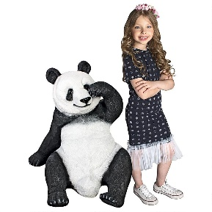

https://www.designtoscano.com/product/australian+outback+kangaroo+statue+-+ne100105.do?sortby=ourPicks&refType=&from=Search $575.00

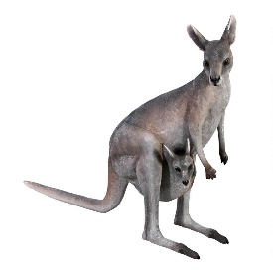

https://www.designtoscano.com/product/zairen+zebra+animal+garden+statue+ng32550.do?p from=Search&cx=0 $375.00

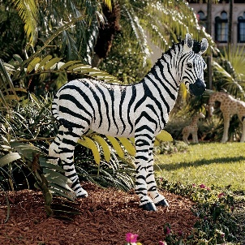

https://www.designtoscano.com/product/woodland+buck+deer+statue+-+ly88195.do?sortby=ourPicks&refType=&from=Search $235
