Cultural Books for HEF Grant

4th Grade (1 set per grade of 20 books):
The Boys with No Names
The Year of the Boar and Jackie Robinson
Chinese Cinderella by Adeline Yen Mah
The Year of the Dog by Grace Lin

Fractured Fairy Tales for STEM (3rd Grade):

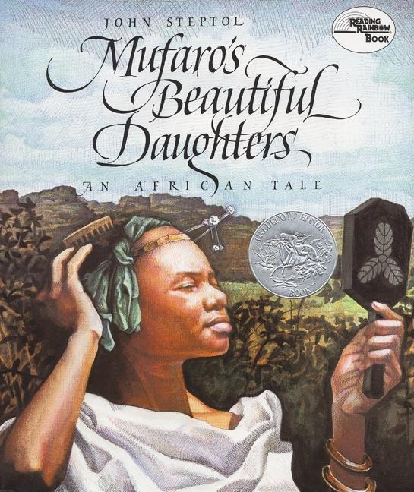Mufaro's Beautiful Daughters by John Steptoe
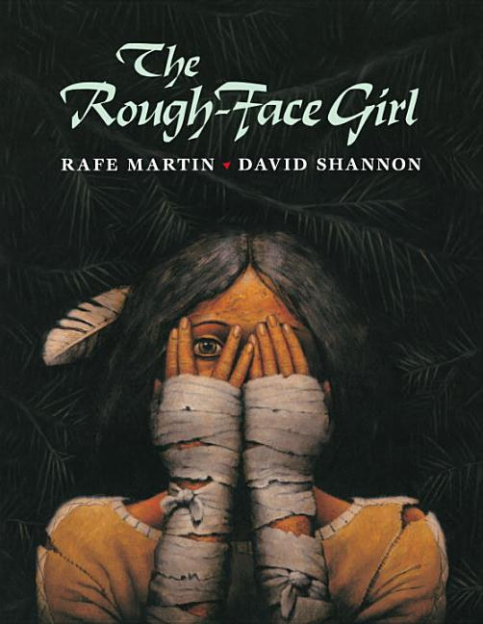The Rough-Face Girl by Rafe Martin and David Shannon
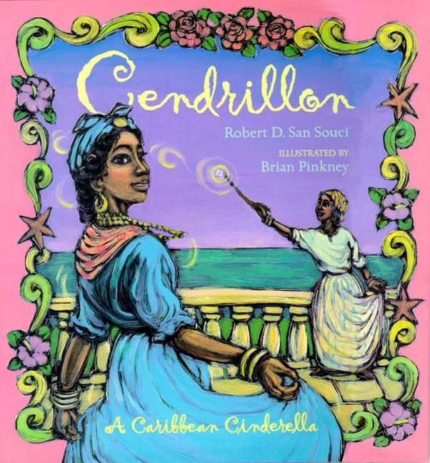Cendrillon: A Caribbean Cinderella,by Robert D. San Souci and Brian Pinkney
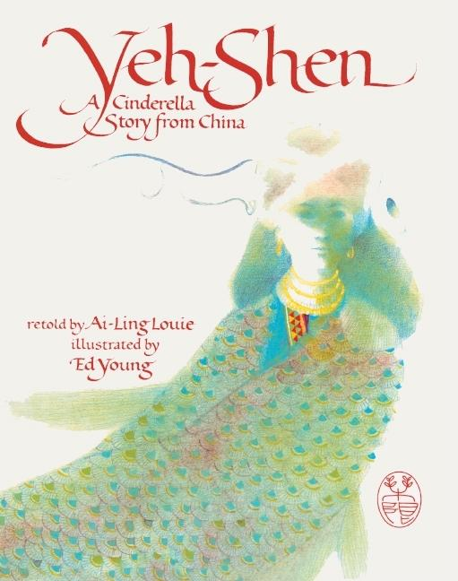Yeh-Shen: A Cinderella Story from China, by Ai-Ling Louie and Ed Young
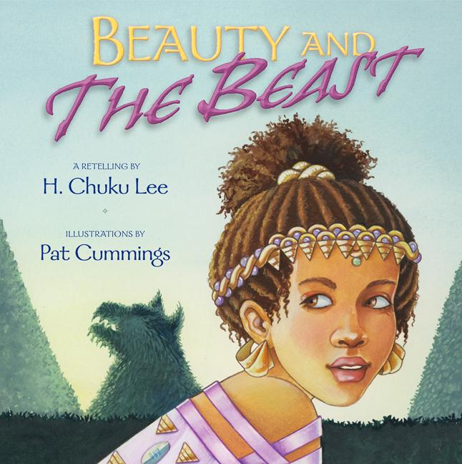Beauty and the Beast, by H. Chuku Lee and Pat Cummings

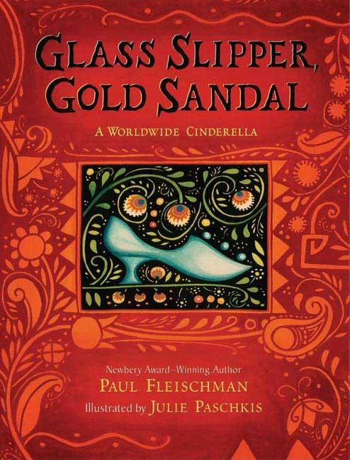Glass Slipper, Gold Sandal: A Worldwide Cinderella, by Paul Fleischman and Julie Paschkis
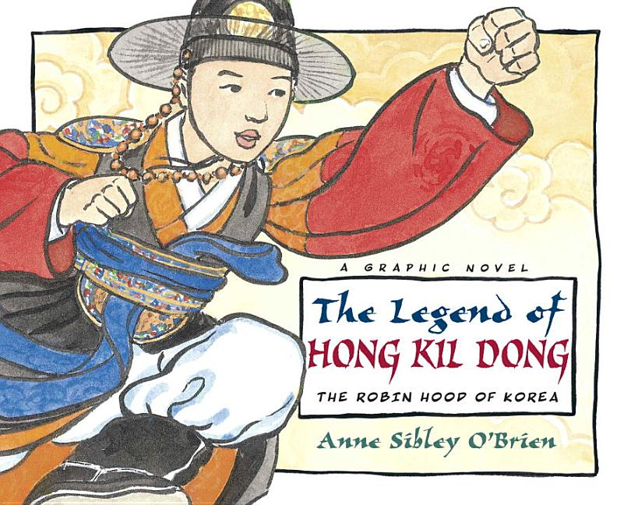The Legend of Hong Kil Dong: The Robin Hood of Korea, by Anne Sibley O'Brien
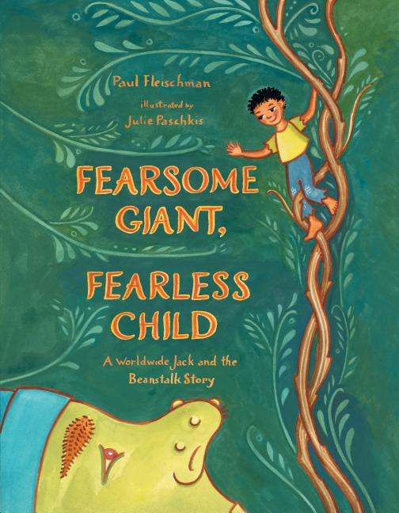Fearsome Giant, Fearless Child: A Worldwide Jack and the Beanstalk Story, by Paul Fleischman and Julie Paschkis
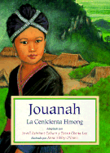Jouanah: A Hmong Cinderella, by Jewell Reinhart Coburn and Anne Sibley O'Brien
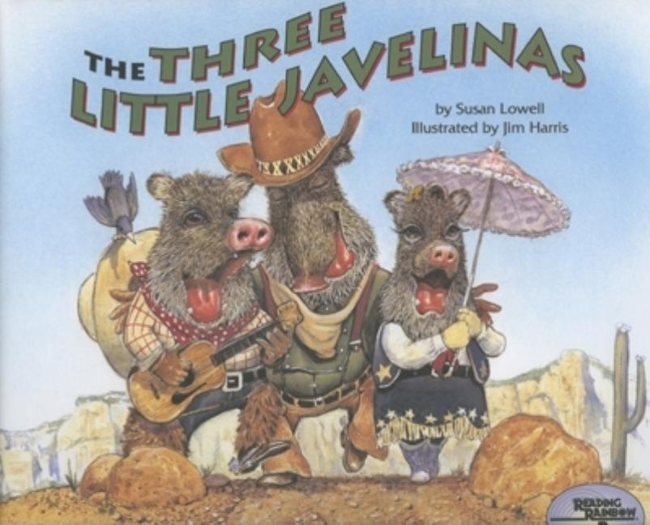The Three Little Javelinas, by Susan Lowell and Jim Harris
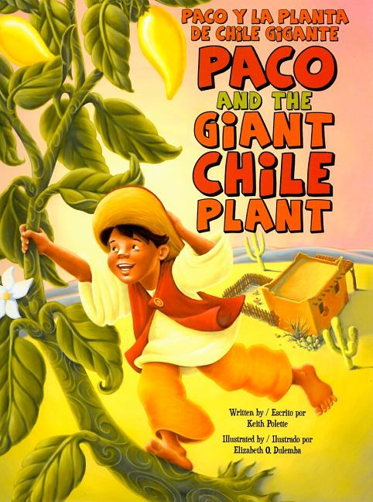Paco and the Giant Chile Plant / Paco y la planta de chile gigante, by Keith Polette and Elizabeth O. Dulemba
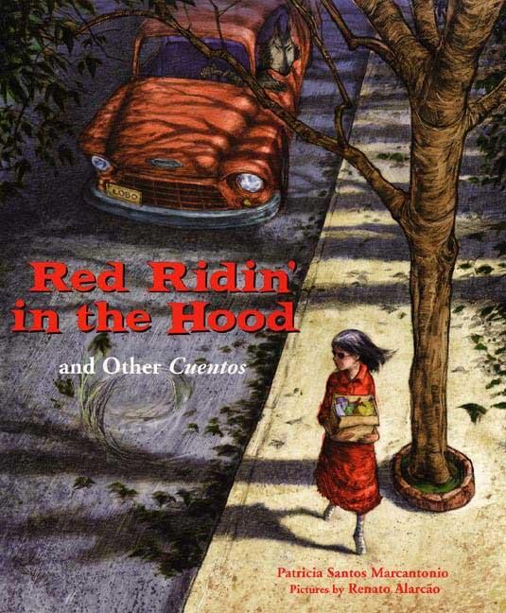Red Ridin' in the Hood: And Other Cuentos, by Patricia Marcantonio and Renato Alarcao
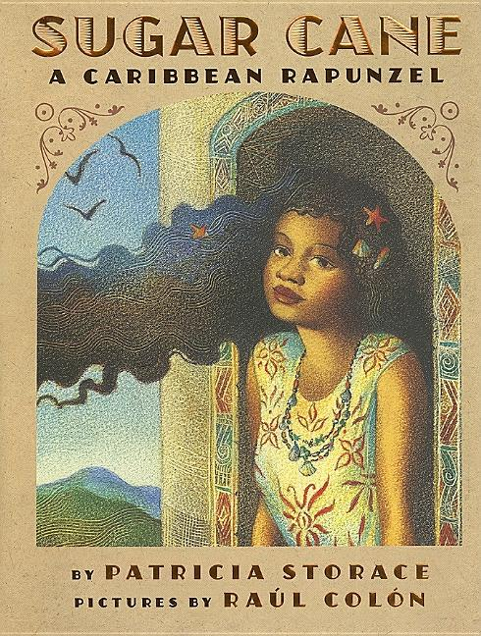Sugar Cane: A Caribbean Rapunzel, by Patricia Storace and Raúl Colón
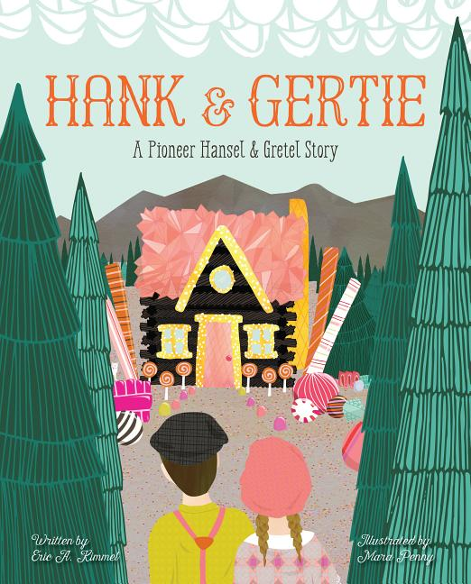Hank and Gertie: A Pioneer Hansel and Gretel Story, by Eric A. Kimmel and Mara Penny
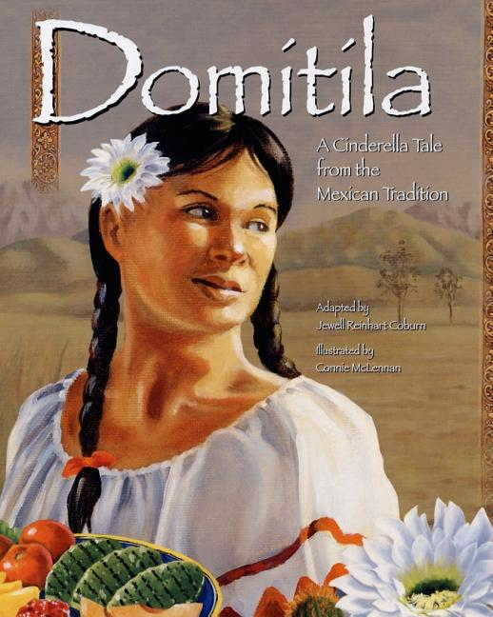Domitila: A Cinderella Tale from the Mexican Tradition, by Jewell Reinhart Coburn and Connie McLennan
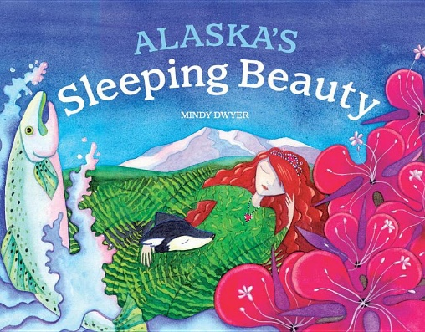Alaska's Sleeping Beauty, by Mindy Dwyer
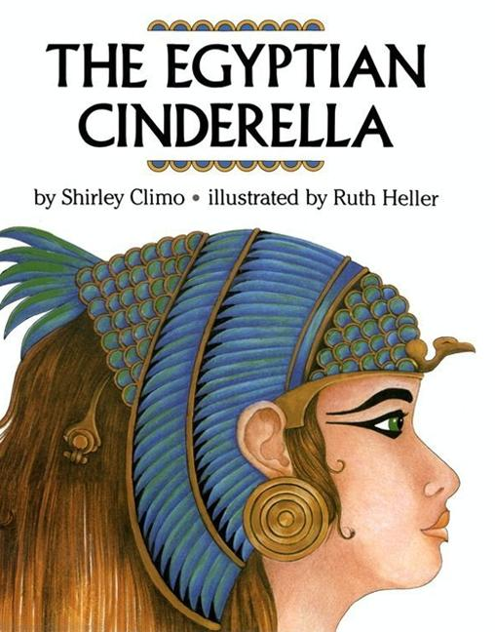The Egyptian Cinderella, by Shirley Climo and Ruth Heller
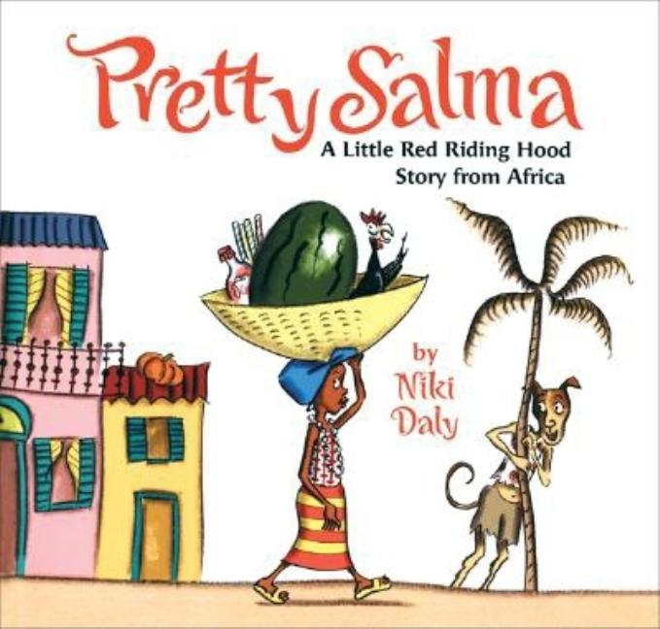Pretty Salma: A Little Red Riding Hood Story from Africa, by Niki Daly
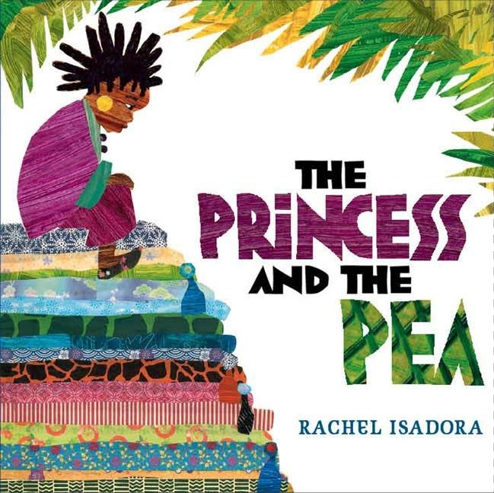The Princess and the Pea, by Rachel Isadora
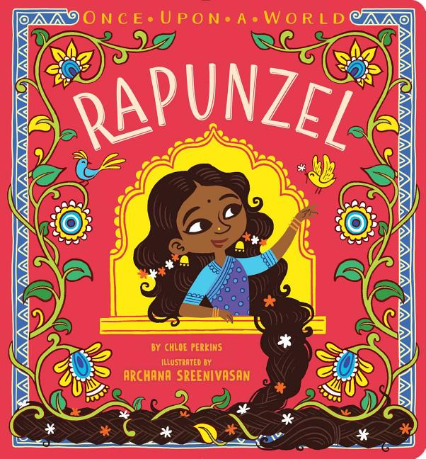Rapunzel, by Chloe Perkins and Archana Sreenivasan
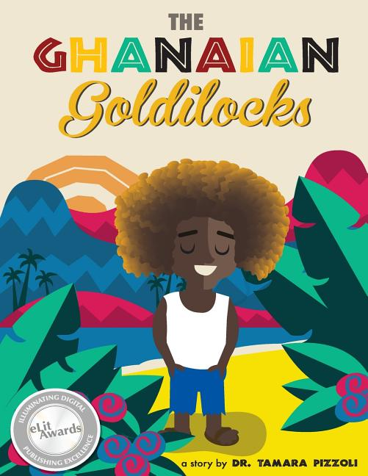The Ghanaian Goldilocks, by Tamara Pizzoli and Phil Howell
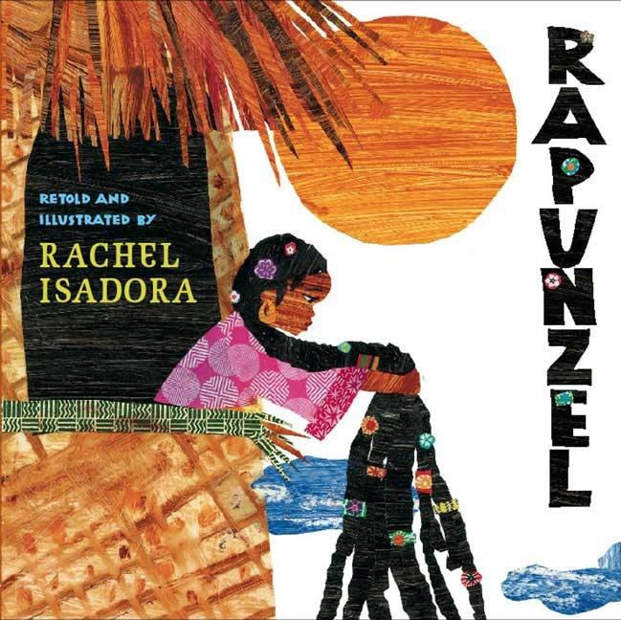Rapunzel, by Rachel Isadora, Wilhelm Grimm, and Jacob Grimm
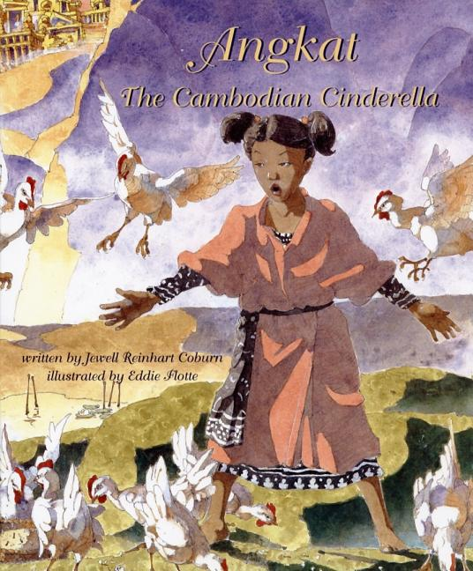Angkat: The Cambodian Cinderella. by Jewell Reinhart Coburn and Eddie Flotte

1st Grade:

Slowly Slowly Slowly said the sloth by Eric Carle
The Dancing Turtle by Pleasant DeSpain
Soccer Star by Mina Javaherbin
Carolina's Gift by Katacha Diaz
The Rainforest Grew all Around by Susan Mitchell
The Magic bean Tree by Nancy van laan
Up and Down the Andes by Laurie Krebs
Where is the Amazon by Sarah Fabiny
Living in Brazil by Ready to Read
Where is Machu Picchu by Megan Stine
The Incan Empire by Sandra Newman
We're Roaming in the Rainforest by Laurie Krebs
You wouldnt Want to be a Mayan Soothsayer by Rupert Matthews

Kindergarten (3 of each):
