Qwizdom Pictures & Data Results
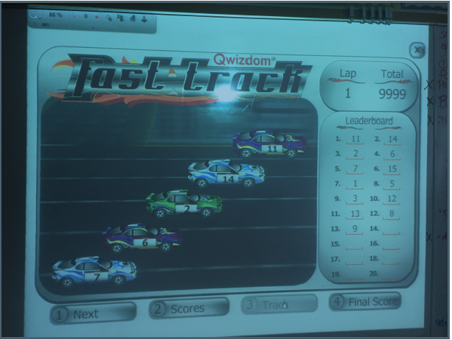
One of many games played.
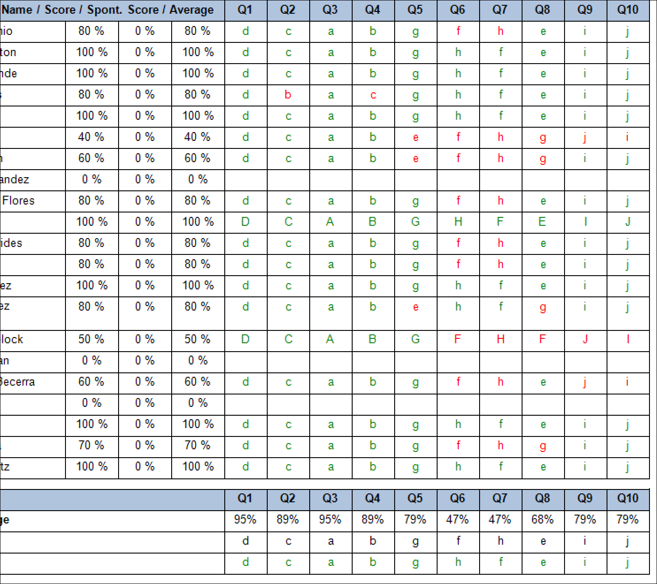
This shows up on the teacher’s computer to show the results. It also gives the averages for each question and average per class for each assignment being used with Qwizdom. (Names were semi-deleted to protect student privacy)
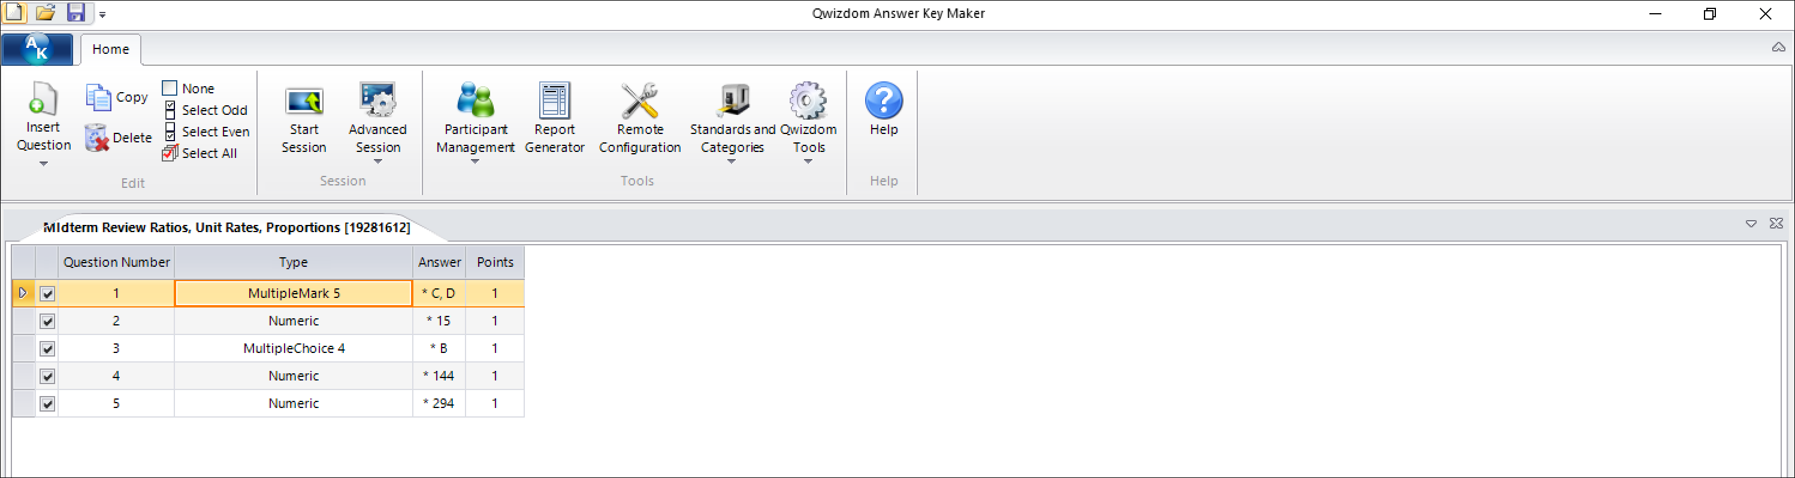
This is an example of the answer key that a teacher would make before creating an assignment for students.

