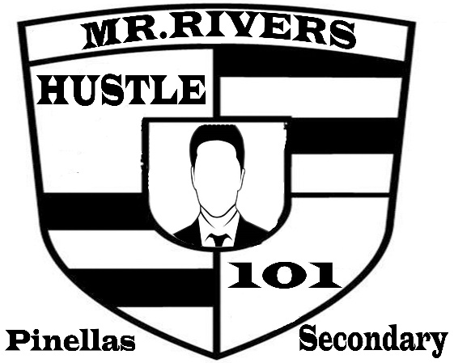

Programs for 2020

We are plain on involving our colleagues to help with our programs:

Ms. Newman and/ or Ms. Grant for our 9-Resolution program. This program goes hand in hand with restorative practice counseling.

The Money Talk Series can incorporate each academic department. Math teachers could help or agree to give extra credit for the budgeting aspects. English teachers might help in the same way with the resumes and essays.

PE Teachers can help with the workout challenges.

We have staff members helping with our Chess Program during Lunchtime

The New Student Inspire Project can be tied into the program that Mrs. Williams is currently doing with our students.

We offer the tutoring programs at lunch that involves all the teachers who’s willing to volunteer their time for our students.

Our Programs serve the many needs of our students and should help them achieve both the grades and points that they will need to leave Pinellas secondary:

We have the writing challenges to help improve students writing, testing and exam skills; both state and school level.

We have the Book Club that promotes reading and understanding. This program helps improve in reading and analyzing what they’ve read. We attempt to pick books related to their interest level as we get them to think and expand how they think as they reach “Higher Levels”.

Our programs are designed to address both the Short and long-term goals of our students.

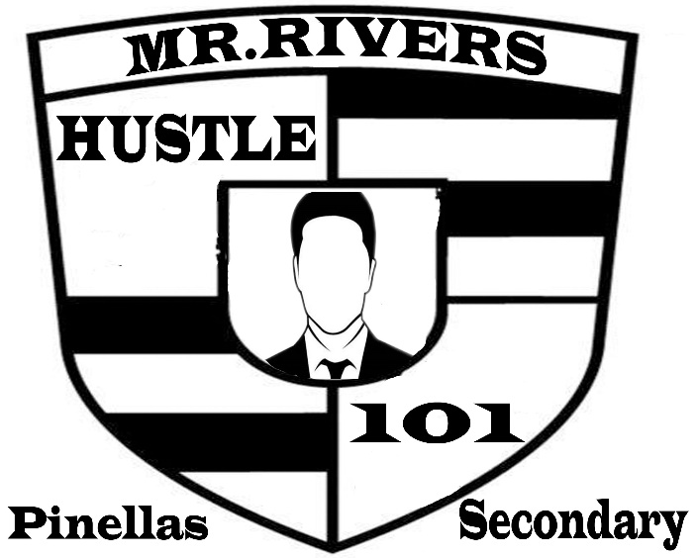

Programs for 2020

We have a variety of activities to appeal to both the students interests and needs:

We have the sports and workout challenges to appeal to students who are fitness focused or just may need to expel their extra energy. This event will be held (Monday-Wednesday-Friday) Girls on Mondays, Boys on Wednesday and Maybe both groups on Friday.

We are starting the Money Talk Series which will be held on (Tuesdays & Thursdays) during lunchtime. This program can go hand & hand with the Finance Park Field trip including bringing out guest speakers from Banks and other companies. Gus Stavros might be helpful.

Our mission is to go above and beyond the norm to reach our students…

