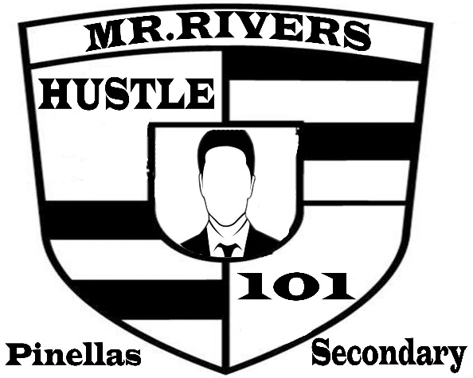

My 9 Resolutions Contest

- Cezar Pastrana
- Lyric Pearson
- Eugene Drain
- Cynthia Jones – Hernandez
- Jeffrey Gilles
- Aliyana Walker
- Diamond Corouthers
- Samara Battles
- Jont’e Cobb
- Knowledge Small
- Marcus Burden
- Terrence Smith
- Alexis Marie
- Jolie Muszak
- Fred Dayton
- Terrell Teague
- Kimberlyn
- Demeko
- Jammal Sullivan
- Taiwan Gland
- Javeion Simmons
- Cameron Walker
- Larry Jenkins
- Kayonna Fields

