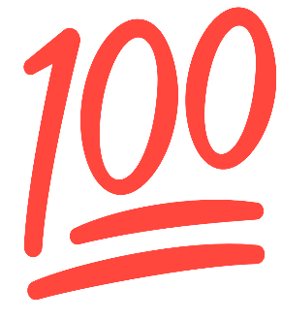
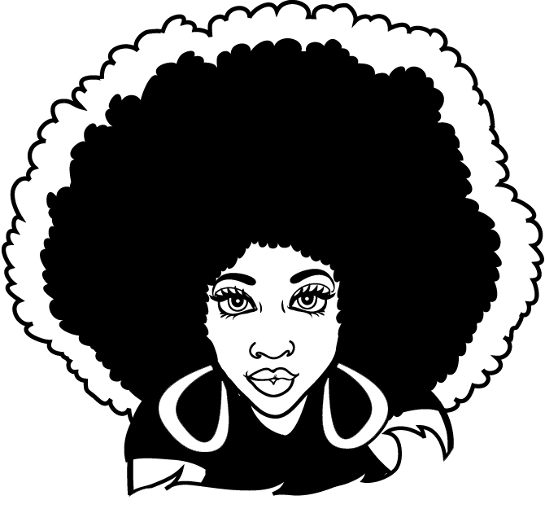

Challenge
Keeping it

1-page essay about learning to Love the Real You…

No Make-up / No Lip gloss / No Weave / No Accessories, Just Natural Beauty
Feb 3rd – 27th
For Top Prize:
No Iss or OSS
Earn Restorative Points

