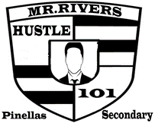
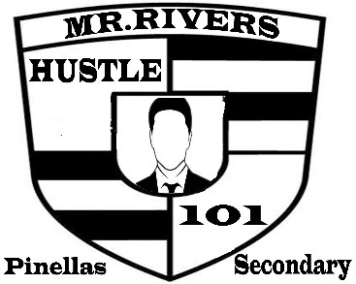
My 9 Resolutions

Students will be tasked to state 9 things / areas that they want to improve upon. These areas of change will be considered short term goals that will be completed by the end of the year.
Areas of change can include the following but not limited to:
Attitude / Behavior / Academics / Personal appearance /Personal Growth / Personal Goals /Reducing Referrals & Suspension / Leaving Pinellas Secondary / Getting out of their own way to achieve success in their life
Students will write down their 9 Resolutions, state why they picked those resolutions & how they will ensure that they achieve success in those 9 areas. Each step must be completed the following way:
Being Slow to Anger / My temper goes from Luke warm to boiling hot in a matter of seconds; I know this emotion needs to be changed for me to remove the main obstacle that can prevent me from achieving peace in my life. I am that main obstacle. / The steps that I will take to improve upon my anger issues is by stopping & praying before I speak followed by taking deep breaths, focusing on inhaling positive thoughts as I exhale negative feelings. I will then imagine how my grandmother would feel if she saw or heard me letting my emotions get the better of me. This is one person that I never want to disappoint. I will remove myself from the issue that could cause me to act in a negative manner / I realize that this change will not occur overnight, but I will work on it daily and keep track of all my success.

Everyone who competes in this contest will earn Restorative Points including admission to the Pizza Party. There will be prizes for the top 3 contest winners

