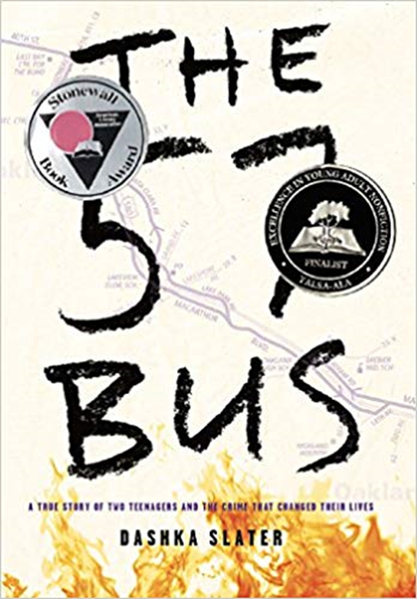
Hustle 101 presents…
Book Club
Assignments for each meeting will be given with your books, and due upon arrival to meeting.

Book talk one time per week. Dessert and snacks served.

4 book talk meetings:
- January 23– 6th period – location - Cafeteria
- January 30- 6th period -location - Cafeteria
- February 6 – 6th period -location - Cafeteria
- February 13 – 6th period – location - Cafeteria

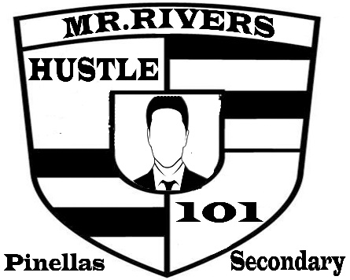
Earn Restorative Points

