Forest Ecosystem

Introduction:
This interactive computer simulation helps students see the effects that human activity can have on a natural habitat. Students get the opportunity to forward through the years and observe the change in the natural forest ecosystem with and without human intervention. Students can allow one of two human activities in this simulation to occur: hunting and lodging, and they can also allow both at the same time. Students can control the starting amount of four organisms in the forest: bears, deer, trees, and mushroom. As they advance through the years, the data screen shows the change in the amount of all four organisms.

The activity is student-lead and requires very minimal teacher assistance. It is to be done the computer lab and the teacher needs to assign partners and computer stations for the students to allow for minimal management. The instruction sheet provides space for students to record their predictions and answers. The simulation requires the teacher to sign up to a free 30 trail using the teacher category, which allows the addition of a class up to 35 students.

Advantages of the simulation:
- No safety concerns
- No equipment or materials needed because students are using only computer
- It allows students to fast forward time to observe change
- It is intentional, it explains the affect of human interaction on the ecosystem through the observable change as time progresses
- It is interactive and allows for manipulation of human activity and numbers of organisms in each species
- Speed is controlled by the students
- The instruction sheet allows for prediction and cooperation in thinking
- The instruction sheet also students to move through incremental learning
- Students can view the change in a line-graph format
- Not time consuming; it will take one class period to complete the simulation. However, extra time may be needed for the extension.

Limitations of the simulation:
- It does not show other factors that could have an affect on the ecosystem, such as weather conditions and natural disasters
- It only shows four different species in the forest (not true in real life)
- Not very consistent: the change in the number of organisms differs every time the simulation is conducted
- Students can only increase or decrease the starting number of organisms, but not type in a certain number

Curriculum Outcomes
7-1-05 Identify and describe positive and negative examples of human interventions that have an impact on ecological succession or the makeup of ecosystems.

7-1-06 Identify environmental, social, and economic factors that should be considered in the management and preservation of ecosystems.
Examples: habitat preservation, recreation, employment, industrial growth, resource development

7-1-07 Propose a course of action to protect the habitat of a particular organism within an ecosystem.
Examples: protect the nesting habitat of a given bird in a local wetland

Explanation of the Simulation Sequence
See attached instruction sheet for students.

Accompanying Discussion
See conclusion of the instruction sheet.

Extension Activity/Questions
See attached at the end.

Reference:
www.explorelearning.com
Grade 3-5
Life Science
Ecology
Forest Ecosystem

http://www.explorelearning.com/index.cfm?method=cResource.dspView&ResourceID=639
Forest Ecosystem

Objectives:
The purpose of this activity is to familiarize you with the impact that human activity can have on the natural habitats of an ecosystem. You will be fast forwarding through the years to see the change in the forest as you apply some human activity. The instructions below will guide through the activity. ANSWER the questions in order as you go through it.

For this activity, you will work with your assigned partner. Each pair has an assigned computer but you will fill out your own worksheet. You should share the responsibility of using the computer, one person at a time but you each of you should get a chance to work with the computer. Both of you should be recording answers. Now find your assigned partner and computer and let’s get started!

Enrolling and Information
Open Internet Explorer or Mozilla Firefox
Type in the following URL:
http://www.explorelearning.com/index.cfm?method=cUser.dspInputClassCode&bypassLogin=1

Type in the class code: HTZAXNEBH6
Click on the ‘Enrol’ button
Click on the ‘Yes’ button to confirm class enrolment.
Enter your first and last name (use only one of your names). DO NOT enter your email address. Your username will be both your first names. Choose a password that you’ll both remember. Once you have entered in this information, click on the ‘submit’ button.

Now you’re logged in and ready to start!
Part A:
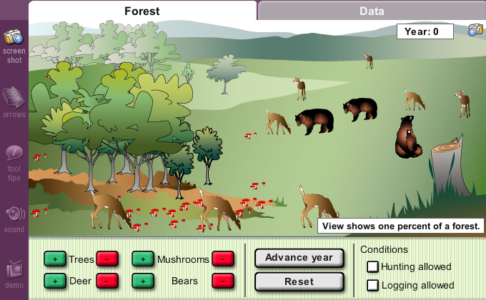
You will see the activity: Forest Ecosystem.
Click on Launch Gizmo. This will take you to the screen that you’ll be conducting the activity on. You will see two taps at the top: Forest and Data. For this assignment you will be working on the Data tab. Click on the Data tab.

Familiarize yourself with the screen before we begin:
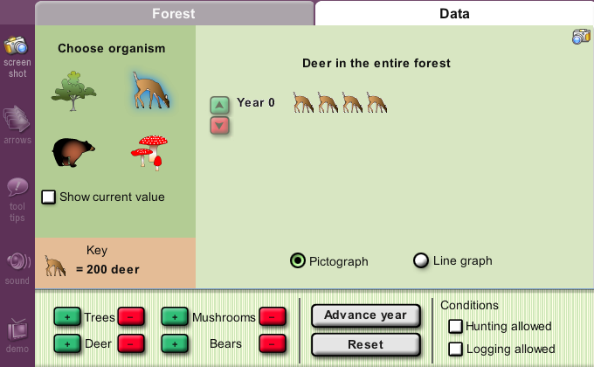
You will be able to control the starting amount of four organisms: trees, mushrooms, deer, and bears. Click on the check box beside ‘Show current value’ to show you the amount. You will be recoding this number later.

To increase or decrease the amount you can click on the [+] or [-] button for each organisms. You can also click on the reset button to reset the amounts back to the default.

You can allow hunting, lodging, or both. We will examine all the possibilities.

Ok let’s begin without allowing any human activity.

Click on each organism and record the starting amount (year 0) for each one of them.
Trees:________ Mushrooms:_______
Deer:________ Bears:_________

Without any human activity, what do you think will happen to the amount of organisms in each species after one year? State if you think the amount will increase, decrease, or stay the same and explain why you think so?
Trees:________________________________________________________
Mushrooms:___________________________________________________
Deer:_________________________________________________________
Bears:________________________________________________________

Click on the ‘Advance year’ button. What happened to the amount of organisms in each species? Record the number and state if it increased drastically, increased slightly, decreased drastically, decreased slightly, or stayed the same.
Trees:________________________________________________________
Mushrooms:___________________________________________________ Deer:_________________________________________________________
Bears:________________________________________________________

In your own words, explain why this happened?
_______________________________________________________________________________________________________________________________________________________________________________________

What do you think the numbers will be like at year 10 for each species? You don’t have to guess the number, just state what you think will happen to each species (ie. Stay the same, somewhat consistent, increase drastically, increase slightly, decrease drastically, or decrease slightly). Briefly explain why you think so.
____________________________________________________________________________________________________________________________________________________________________________________________________________________________________________________

Advance to year 10 and record the numbers below.
Trees:________ Mushrooms:_______
Deer:________ Bears:_________

Was the change a negative or positive change? Explain why.
__________________________________________________________________________________________________________________________

Predict what will happen at year 20 and tell your partner. Advance to year 20 and record the numbers below.
Trees:________ Mushrooms:_______
Deer:________ Bears:____________

Now that you have seen the forest ecosystem change over 20 years, do think these species have a good future in the forest? Briefly explain why.
_________________________________________________________________________________________________________________________________________________________________________________________________________________________________________________________

Part B:
Let’s change things up a little bit! We’re going to allow hunting.

Click on the ‘reset’ button (it is below the advance year button)
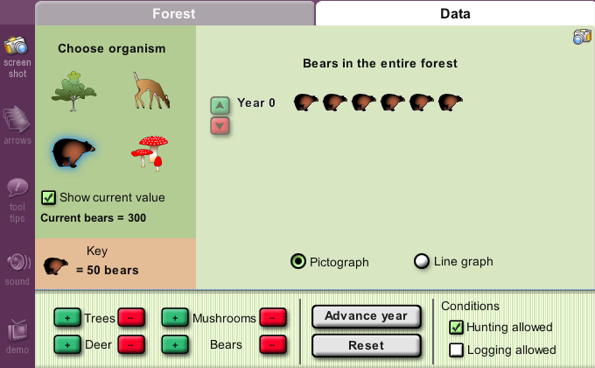
Click the check box beside
‘hunting allowed’

Ensure that you have the same starting number of organisms as in part A.

Now that we have allowed hunting in the forest ecosystem, what do you think will happen to the amount of organisms in each species after one year? State if the amount will increase or decrease and explain why you think so?
Trees:________________________________________________________
Mushrooms:___________________________________________________
Deer:_________________________________________________________
Bears:________________________________________________________

Advance to year 1 and record the numbers for each species below.
Trees:________ Mushrooms:_______
Deer:________ Bears:____________

For each species state what change happed and explain the reason for the change in you own words.
____________________________________________________________________________________________________________________________________________________________________________________________________________________________________________________What do you do you think will happen in ten years if we continue to allow hunting? State what you think will happen to the numbers of each species (ie. Stay the same, somewhat consistent, increase drastically, increase slightly, decrease drastically, or decrease slightly). Briefly explain why you think so.
____________________________________________________________________________________________________________________________________________________________________________________________________________________________________________________

Advance to year 10 and record the numbers below.
Trees:________ Mushrooms:_______
Deer:________ Bears:_________

Was the change a negative or positive change? Explain why.
_______________________________________________________________________________________________________________________________________________________________________________________

Predict what will happen at year 20 and tell your partner. Advance to year 20 and record the numbers below.
Trees:________ Mushrooms:_______
Deer:________ Bears:____________

Now that we have allowed hunting for the past twenty years, what do you think will happen if hunting continues? Can the animals go extinct? Briefly explain why.
____________________________________________________________________________________________________________________________________________________________________________________________________________________________________________________

After twenty years, how do the results in part B (hunting allowed) differ from the results in part A (no human activity)? Explain the reason for the difference.
__________________________________________________________________________________________________________________________
__________________________________________________________________________________________________________________________
Part C:
Let’s see what happens if we allow logging but not hunting.
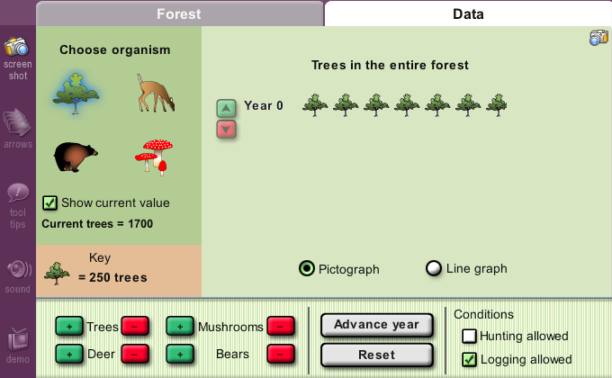
Click on the ‘reset’ button

Check off hunting by clicking on the check box by ‘hunting allowed’

Click on the check box beside ‘Logging allowed’

Ensure that you have the same starting number of organisms as in part A.

Now that we have allowed logging in the forest ecosystem, what do you think will happen to the amount of organisms in each species after one year? State if the amount will increase or decrease and explain why you think so?
Trees:________________________________________________________
Mushrooms:___________________________________________________
Deer:_________________________________________________________
Bears:________________________________________________________

Advance to year 1 and record the numbers for each species below.
Trees:________ Mushrooms:_______
Deer:________ Bears:____________

For each species state what change happened and explain the reason for the change in you own words.
____________________________________________________________________________________________________________________________________________________________________________________________________________________________________________________
What do you do you think will happen in ten years if we continue to allow logging? State what you think will happen to the numbers of each species (ie. Stay the same, somewhat consistent, increase drastically, increase slightly, decrease drastically, or decrease slightly). Briefly explain why you think so.
____________________________________________________________________________________________________________________________________________________________________________________________________________________________________________________

Advance to year 10 and record the numbers below.
Trees:________ Mushrooms:_______
Deer:________ Bears:_________

Was the change a negative or positive change? Explain why.
__________________________________________________________________________________________________________________________

Predict what will happen at year 20 and tell your partner. Advance to year 20 and record the numbers below.
Trees:________ Mushrooms:_______
Deer:________ Bears:____________

What effect did logging have on the trees?
_____________________________________________________________

If we were only cutting trees, then why did the amount of deer and bears decrease?
_______________________________________________________________________________________________________________________________________________________________________________________

Did the animals go extinct? ______
If so, what year did this happen? __________
Why do you think this happened?
_______________________________________________________________________________________________________________________________________________________________________________________

What can humans do to avoid extinction but still do some logging?
__________________________________________________________________________________________________________________________

Part D:
Now we know the effects that hunting can have on a natural habitat and we also know the effects that logging can have on a natural habitat.

What do you think will happen if we allow hunting and logging to happen at the same time? Will animals go extinct? If so, how fast do you think it happen?
_______________________________________________________________________________________________________________________________________________________________________________________

Let’s try it and see what happens. Make sure both check boxes (hunting and logging allowed) are checked and advance through the years. What happened to each species?
____________________________________________________________________________________________________________________________________________________________________________________________________________________________________________________

Conclusion: (you must finish the experiment and answer all questions before moving on to this section)

A natural habitat or an ecosystem can be negatively affected by human activity. We have seen two activities that had a negative on the forest ecosystem throughout the years. First we looked at hunting in the forest. After some years, the amount of deer dramatically decreased, which caused the amount of mushrooms and trees to increase because there is less deer feeding on them. The number of bears decreases slightly for two reasons: they are not hunted as much as deer and they did not have to share their food with as much deer. Eventually, after many years, the deer becomes extinct due to over-hunting. This could also affect other organisms in the ecosystem, that may depend on deer for survival.

We also looked at how logging affects the forest ecosystem. When the number of trees decreased (due to logging), the animals had to resort to the mushrooms for food. Eventually, the deer and bears are unable to survive because of the decrease in food. The trees made up a large part of the habitat for these animals and once taken away, the animals could not survive. In the long run, logging also caused extinction of both animal species. This is an example of how human activity can indirectly affect animal species.

We can prevent the negative impact that logging and hunting has on the forest ecosystem. Fore example we can limit the amount of animals hunted per year. We can also limit the amount of trees being cut and plant five times as much trees as we cut.

There are many other ways that human activity can have a negative affect on a natural habitat. These include preventing natural fires, introducing non-indigenous species, and draining wetlands for agriculture or housing. Some human activity can have a positive affect on natural habitat. These include protecting habitats and reintroducing species.
Let’s Extend!!

You have just witnessed a negative effect that human activity can have on a natural habitat. List a human activity that is currently having a negative affect on the environment or other types of natural habitats. Who is the activity negatively affecting?
_____________________________________________________________

Write a letter informing someone about this. You can address the letter to the government, your favourite magazine, your local community, a global organization, etc. You must include the following points in your letter. What is the human activity? What environment or habitat is being affected? List one organism that is negatively affected by this? How does the human activity affect this organism and the environment/habitat? Who else is affected by this? What is the future of the organism if this human activity continues? Finally propose a solution that can help preserve this organism within its ecosystem or habitat: What can we do to preserve the organism/habitat/environment and how will this help? When you’re done, read the letter to your partner, type it, proof read it, and print it.
________________________________________________________________________________________________________________________________________________________________________________________________________________________________________________________________________________________________________________________________________________________________________________________________________________________________________________
________________________________________________________________________________________________________________________________________________________________________________________________________________________
________________________________________________________________________________________________________________________________________________________________________________________________________________________________________________________________________________________________________________________________________________________________________________________________________________________________________________
________________________________________________________________________________________________________________________________________________________________________________________________________________________ ________________________________________________________________________________________________________________________________________________________________________________________________________________________________________________________________________________________________________________________________________________________________________
________________________________________________________________________________________________________________________________________________________________________________________________________________________
________________________________________________________________________________________________________________________________________________________________________________________________________________________________________________________________________________________________________________________________________________________________________
________________________________________________________________________________________________________________________________________________________________________________________________________________________

