Qwizdom Pictures & Data Results
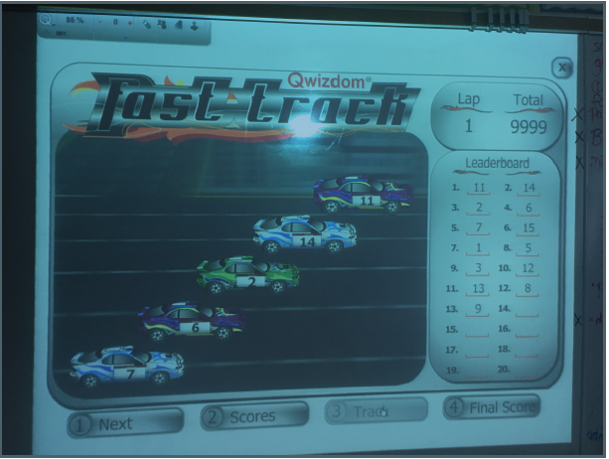
The above is the car game that students play with the entire class. This is displayed on the white board once all students have answered as they race against each other.
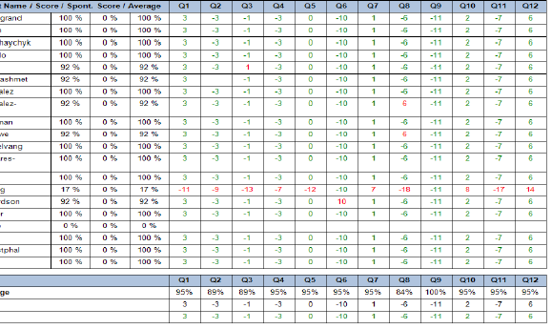
This shows up on the teacher’s computer to show the results. It also gives the averages for each question and average per class for each assignment being used with Qwizdom. (Names were semi-deleted to protect student privacy)

