25 POINTS

50 POINTS

NAME ________________ TEACHER _________________

Directions: Checkmark the box or boxes under the item(s) you would like to order. Limit 1 per item.

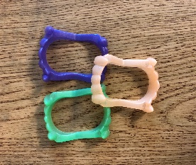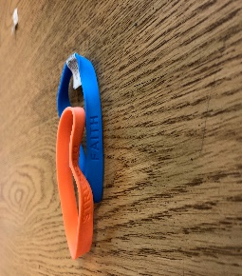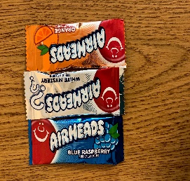

Airheads Candy

Vampire Teeth

Motivation Bracelet

100 POINTS

75 POINTS

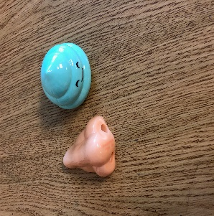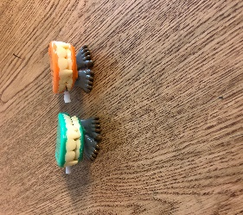

Putty

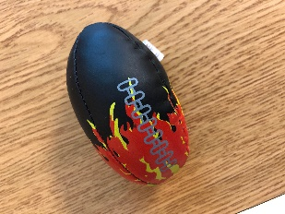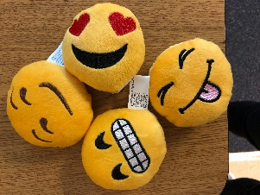

Stuffed Emojis

Fire Football

Wind Up Teeth

Pencil Sharpeners

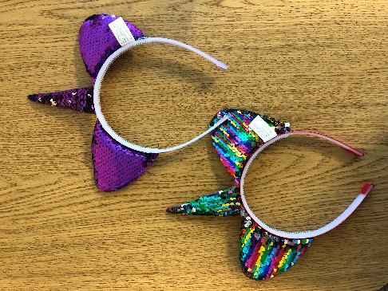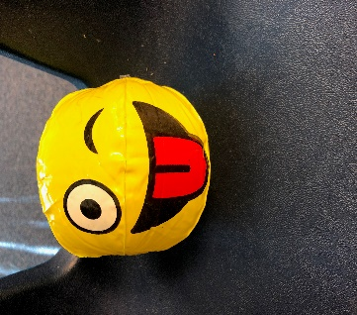

Unicorn Headbands

Blow Up Emoji Ball

150 POINTS