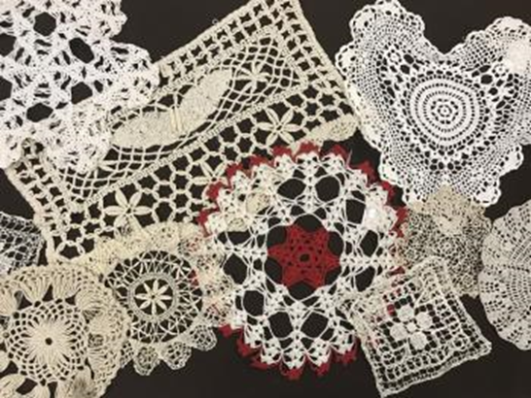
April 26, 2019
Champions for Learning,
I know I have spoken to several of you and we were so thrilled to have you visit our classroom this year and see our work in progress. And, we were honored to be asked to submit trays for your display at the Golden Apple ceremony. The students’ trays have just been beautiful and I am so grateful that your grant provided the ‘tray-making’ GR forms. We will have these forms for years to come and look forward to using them again with this project and in other projects. The students really enjoyed this project and we thank you,
Leslie Loughran
BCHS, Ceramics

