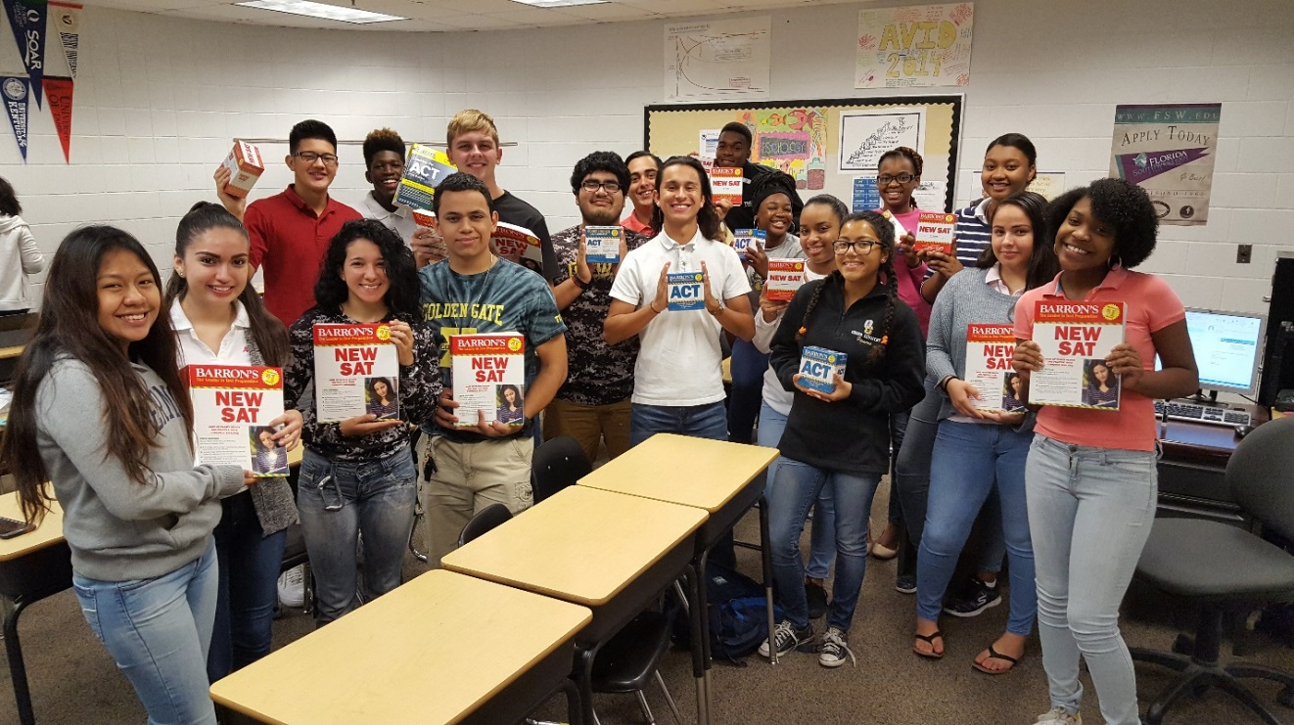
THANK YOU!
Dear Judith S. Palay-
Thank you so much for fulfilling the grant request for the “ACT/SAT Test Prep Materials” here at Golden Gate High School. It will definitely be helpful to the students here as they prepare for these crucial exams, and hopefully the test review material will pay off in higher scores.
The students here at Golden Gate are always very thankful and grateful for the support they get from community members. Since we received your grant and purchased the flash cards and test prep books, they have all been checked out on a regular basis. In fact, the day they arrived and were made available to my students, one girl was so excited because she had planned on going to Barnes & Noble that afternoon to buy one. You saved her a bit of her hard earned money that she earns from her after school job.
Like I said, HOPEFULLY this material will pay off with higher ACT and SAT scores, which will result in more acceptance letters and higher scholarship amounts!

Greg Anderson
Golden Gate High School

