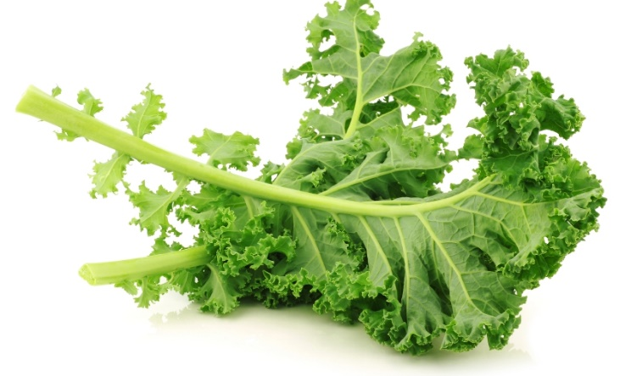
Vitamin C in Plants Test Report

Abstract of Experiment
The purpose of this experiment was to determine if adult plants or plant sprouts have higher nutrition levels in regard to vitamin C. To test this, kale sprouts and adult kale was ground and mixed with water and a starch solution. Iodine was then slowly added to the mixture, which helped to determine the concentration of vitamin C in both of the samples. It was determined that adult plants have a higher concentration of vitamin C than plant sprouts do, with adult kale having .46 mg of vitamin C per gram of kale more than kale sprouts.

Introduction
Vitamin C is an essential water-soluble vitamin that is present in many fruits and vegetables, such as kale. Vitamin C is a powerful antioxidant that helps in the formation and maintenance of connective tissues. Vitamin C has a variety of other purposes in the body, including aiding in the absorption of iron and helping to prevent heart disease. A deficiency in vitamin C can cause scurvy, a disease that was very prevalent among sailors and pirates between the 16th and 18th century. Symptoms of scurvy include loss of teeth, swelling, ulcers on the gums, anemia, exhaustion and debility. The purpose of this experiment is to compare the vitamin C levels in adult plants and plant sprouts.

Materials and Methods

Materials:
- Kale sprouts
- Adult kale
- Pestle and mortar
- Water
- Iodine
- Beaker
- Dropper
- Scale
- Pipette
- Starch
- Calibration solution

Methods:
Vitamin C Calibration
The first step was to calibrate the amount of iodine needed to react with a set amount of vitamin C. In a test tube, 1 ml of calibration solution, 2 ml of starch solution, and ~5 ml of water are mixed. When this solution is mixed with iodine, it turns a dark purple color, due to the reaction between ascorbic acid (vitamin C) and iodine. Using a pipette, iodine was dropped into the solution until it turned a dark purple color. It took 22 drops of iodine for the solution to turn completely purple. This equates to .45 mg of vitamin C per drop of iodine.
Sprouts
The process for both kale sprouts and adult kale is very similar to that of the vitamin C calibration. The calibration solution is simply replaced with 2 grams of kale sprouts ground into a pulp using a pestle and mortar. The sprouts had the end result of .35 mg of vitamin C per gram of kale.
Adult Kale
The adult kale had an end result of .81 mg of vitamin C per gram of kale.

Results
Adult kale had the higher concentration of vitamin C when compared to kale sprouts. Adult kale had .81 mg/g and kale sprouts had .35 mg/g. That is a difference in concentration of .46 mg/g. The average cumulative data had kale sprouts at 1.782 mg/g and adult kale at 2.099 mg/g. That is a difference in concentration of .317 mg/g.

Discussion and Analysis
According to the results of this experiment, the concentration of vitamin C is higher in adult plants than in plant sprouts. In the experiment, adult kale had a difference of .46 mg/g when compared to kale sprouts. A healthy minimum daily intake of vitamin C is about 80 mg (give or take.) Using our results, one would need to consume 98 grams of kale to reach that level. That’s about a cup and a half of chopped kale. On the other hand, one would need to consume 229 grams of kale sprouts in order to get the same amount of vitamin C.

Reference Citations
Vitamin C Benefits - What Does Vitamin C Do? | Dr. Weil. (2017, February 07). Retrieved March 06, 2017, from https://www.drweil.com/vitamins-supplements-herbs/vitamins/vitamin-c-benefits/
Vitamin C Foods, Signs of Deficiency & Health Benefits. (2015, June 18). Retrieved March 06, 2017, from https://draxe.com/vitamin-c-foods/
Crosta, P. (n.d.). Scurvy: Causes, Symptoms and Treatments. Retrieved March 06, 2017, from http://www.medicalnewstoday.com/articles/155758.php

