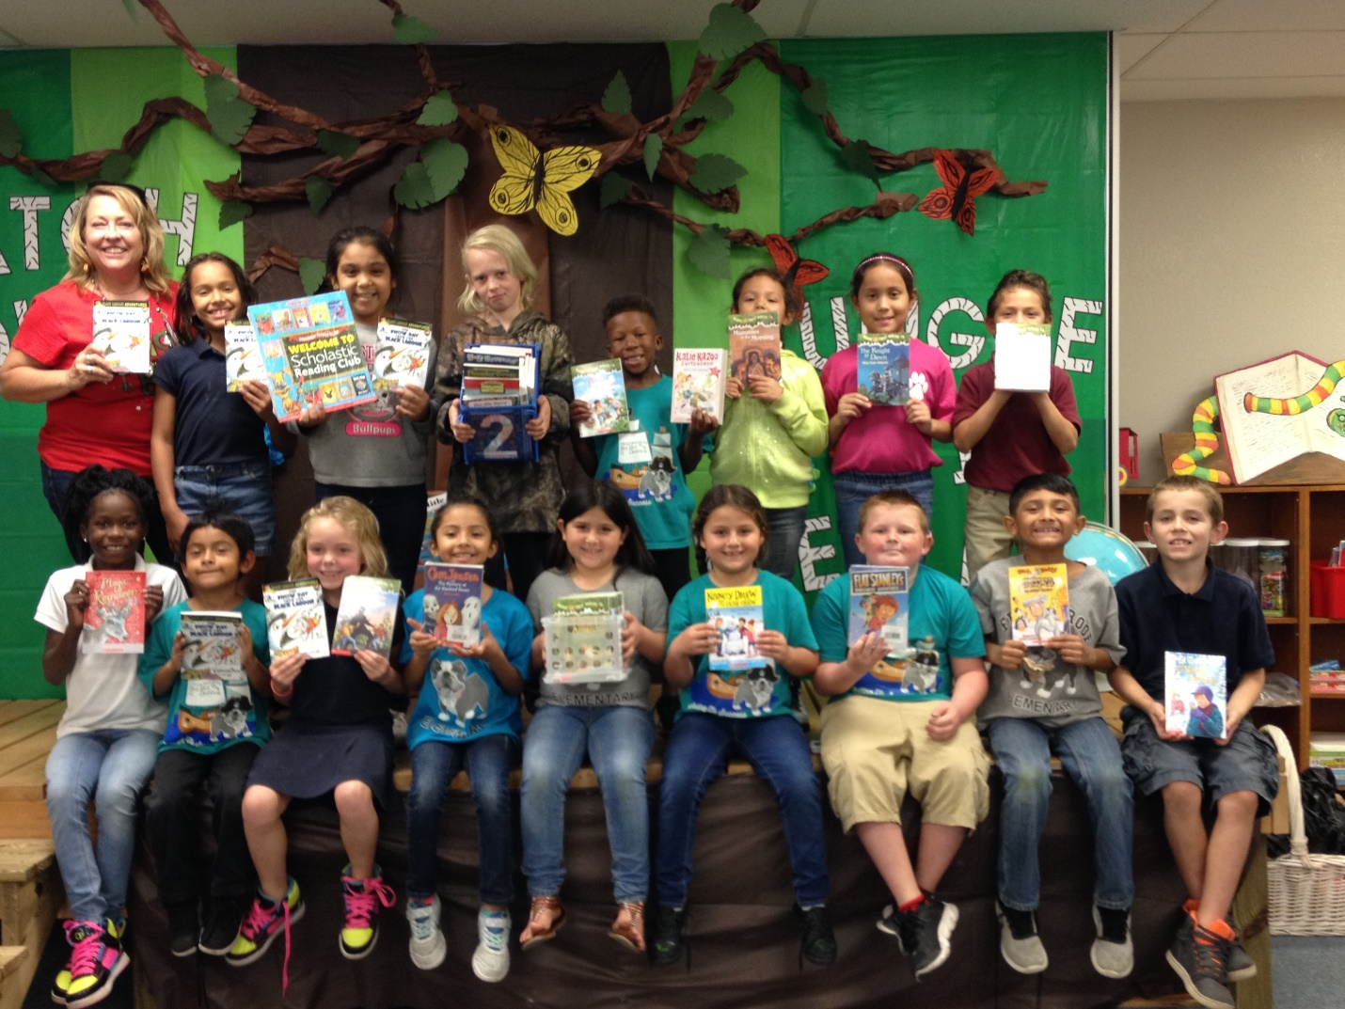 December 16, 2016

Dear Polk Education Foundation and Business Partnership, Inc. P.O. Box 391 Bartow, Fl 33831

RE: Find It & Fund It POLK! – Impact Report

As we come close to ending our 2nd Semester of 2016-17, I am excited to share the thrill of our students when we received our many new classroom books for our classroom library before leaving for our winter break. As you can see from our enclosed pictures, there were too many books [over 100 books of fiction and non-fiction texts] for the students to hold and show off all the books that were purchased through your grant program. However, you cannot help but see the joy and excitement in each of the students’ faces in receiving this great gift!!

My goal upon applying for this program was to place fiction and non-fiction classroom books in our classroom for the students to assist in their reading comprehension. It is a great combination of having appropriate grade level reading material combined with our county’s Accelerated Reading Program [AR] of comprehension quizzes to assess the students’ knowledge of what they have read. This combination peaks the students’ love of reading with the preparation of their future 3rd grade FSA assessment of reading and language requirements.
I want to also thank the Scholastic Book company for assisting me with the best choices of fiction and non-fiction texts and their best book packages to stretch every dollar of my generous donation. All of which will assist these 2nd grade students as they continue to grow into avid readers.
The businesses that support this partnership of Polk Education Foundation have done a great service to not only my students and my future students, but also to all the students of Polk County for giving their financial support to this program.
Thank you to the many businesses that support Find It & Fund It POLK!
The donors that supported my project were: Wells Fargo, Fellow College Graduate Marie Gessler Evans, and Polk Education Foundation.
Sincerely,
Deena L. Dickey [aka- Miss “D”] 2nd Grade Teacher Frostproof Elementary School Frostproof, Fl 33843

