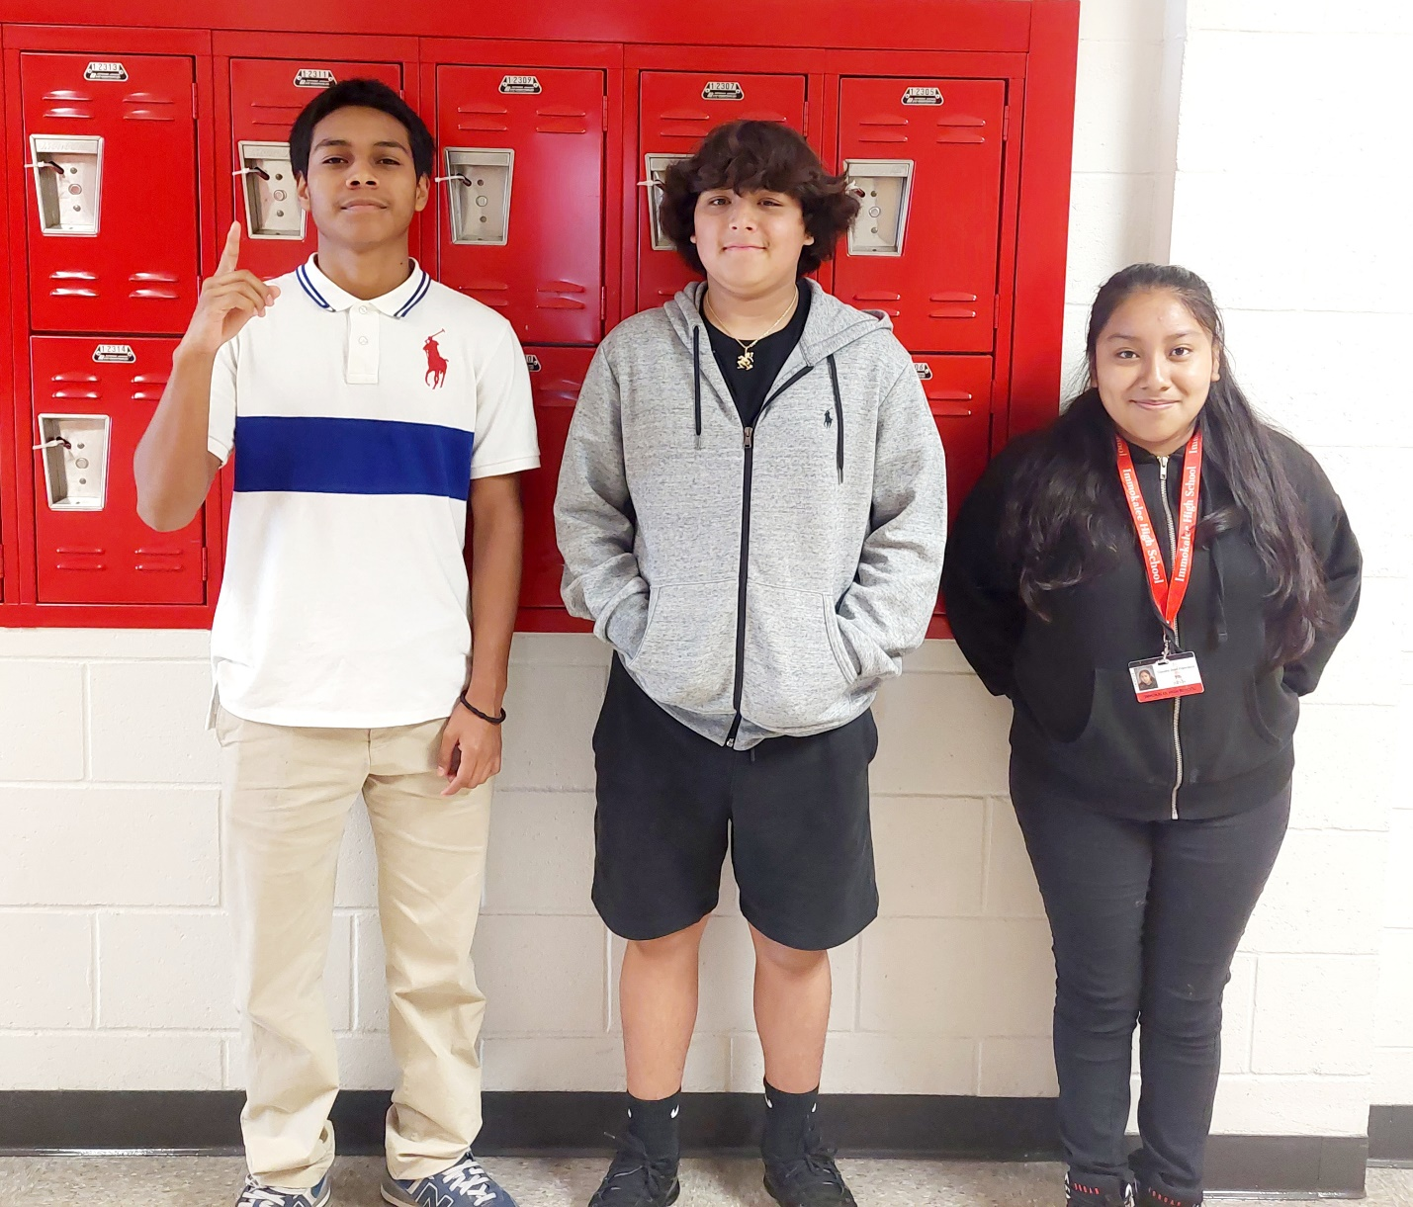
Students who received a level 3 or higher on their Progress Monitoring State Test (FAST PM2) were given prizes and recognized.

