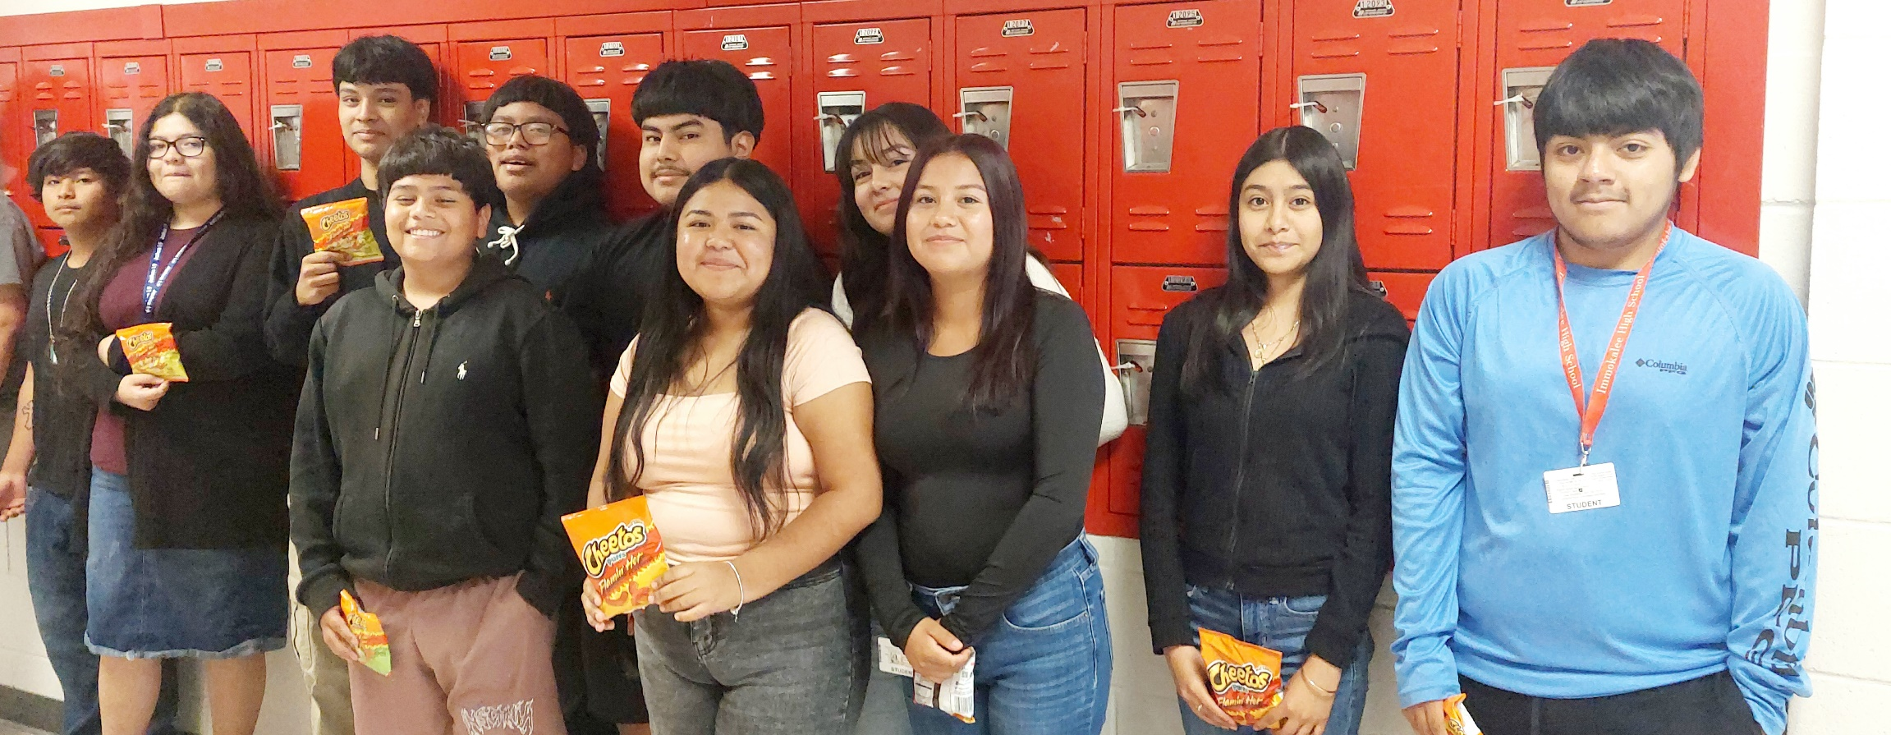
Students in my 4/5 Block who worked hard were rewarded with a bag of chips of their choice. The PBIS incentive helped my students work at their full potential.

