Thank you so much for the equipment and supplies!
My class is a digital art class and I teach my students how to use Adobe Photoshop and Adobe Illustrator.
The students learn how to use the basic tools of the programs in the beginning, then, as their skill with the Adobe programs increases, and their art and design skills become stronger, they start putting their skills to use on bigger projects and are ready to move them off the computer screen onto actual design projects.
One project I have wanted to do with the students was screen printing, which is a traditional art, but with this new equipment, I was able to combine the digital art tools with the traditional screen printing process and the students were really able to bring their projects to life.
Here are the steps the students used to create their t-shirts.
- Students started by creating a black and white design on Adobe Illustrator.
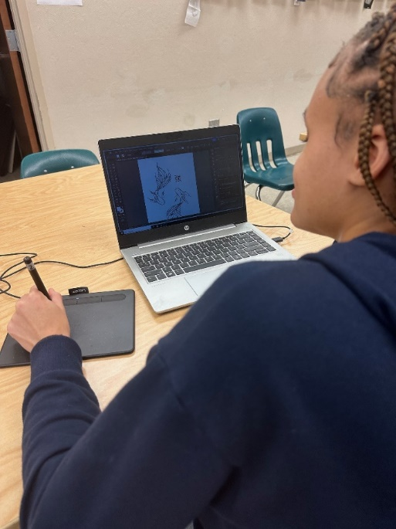
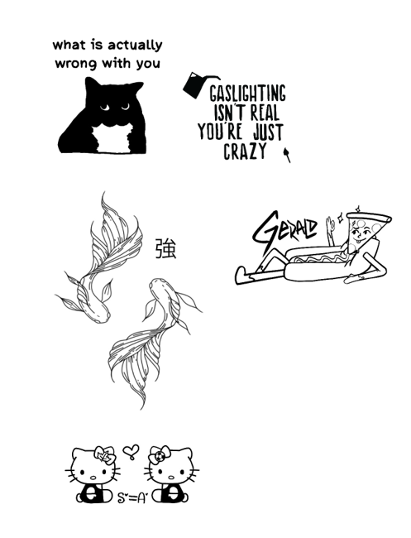
- Students then sent their designs to me, we edited and revised, then put them into the Silhouette Program to set it up for cutting.

3. Students were shown how to set up their designs on the silhouette program to send to the Cameo machine and were able to make final adjustments and refinements.

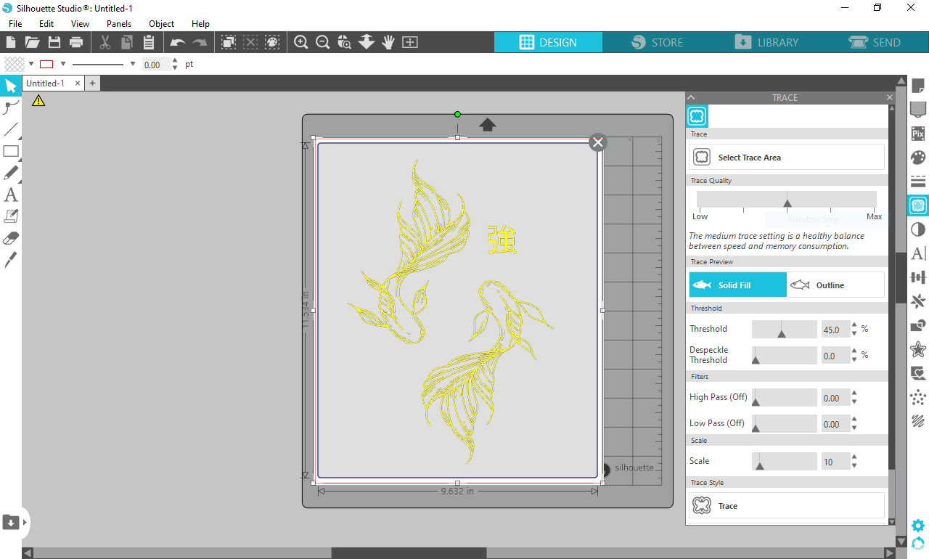

4. The Cameo Machine cut out the student’s design from vinyl according to how the student set it up.
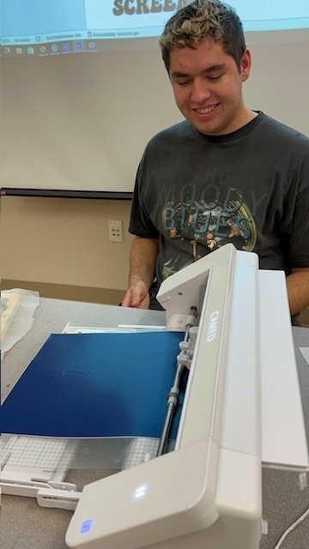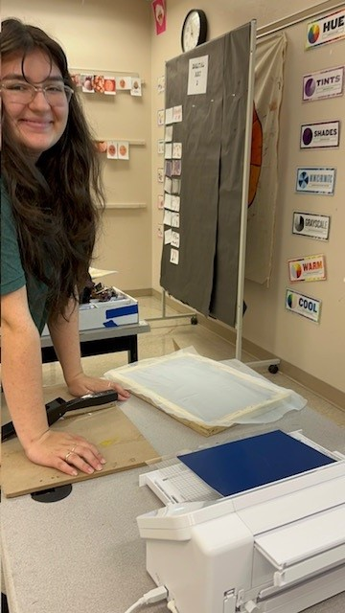

5. Students then removed any extra vinyl from their design.
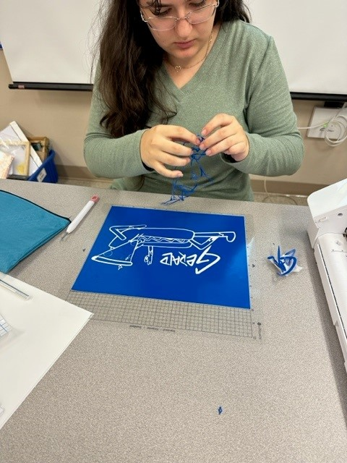
6. Students then transferred their design to the screen using transfer paper.

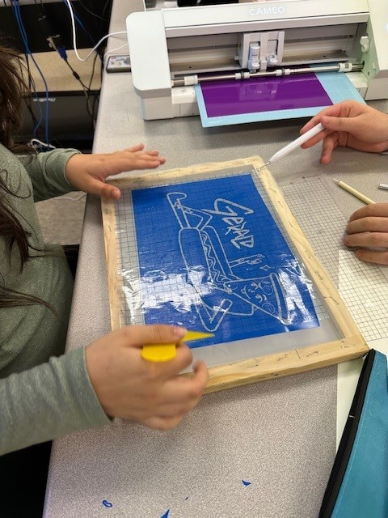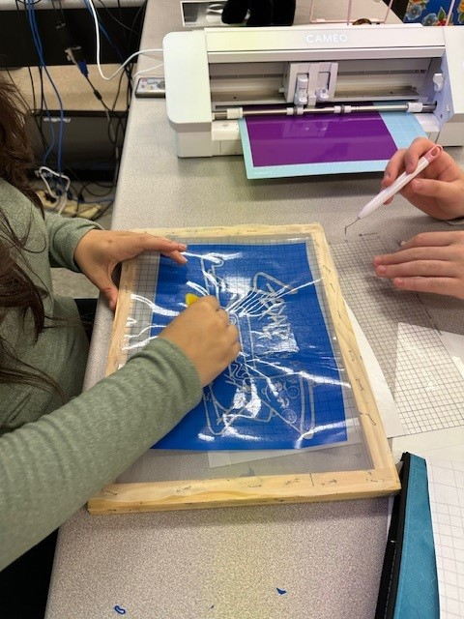

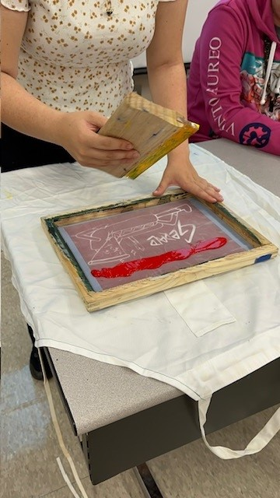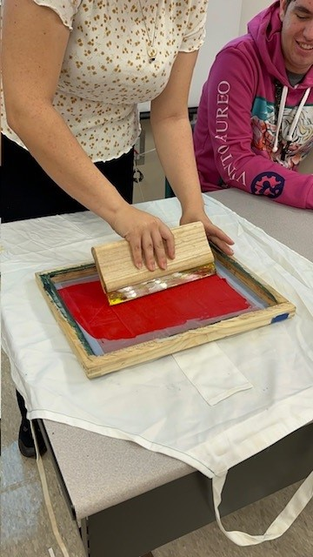
7. Once the vinyl was placed correctly student then chose a color and printed their design on their T shirt.

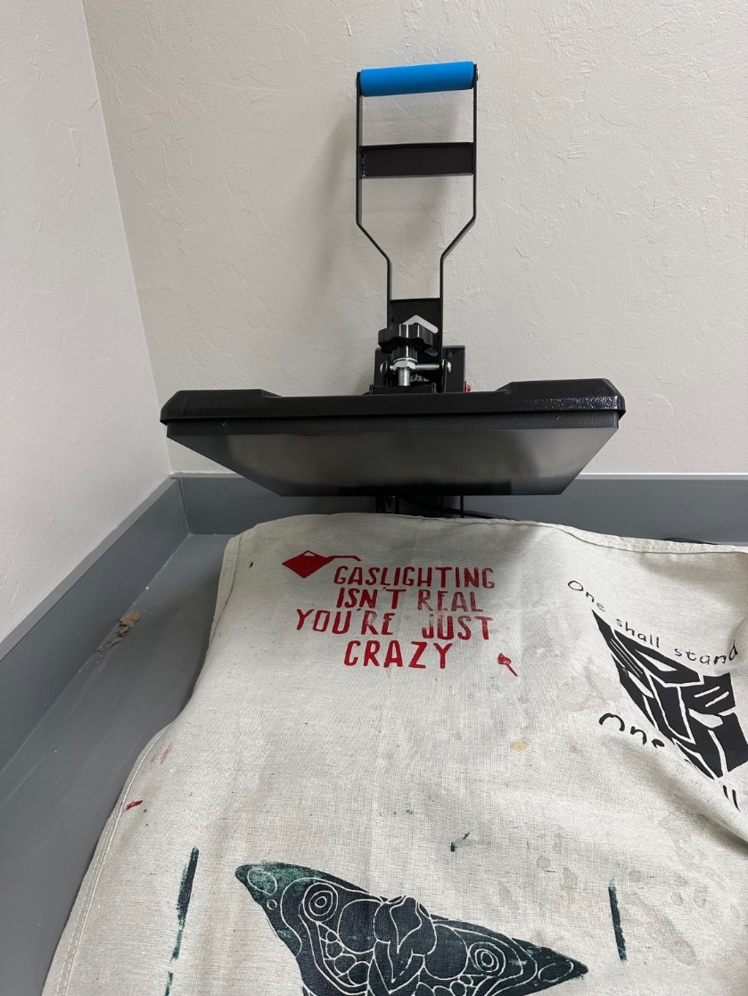
8. Shirts were left to dry over night then pressed down in heat press to help the paint to set.

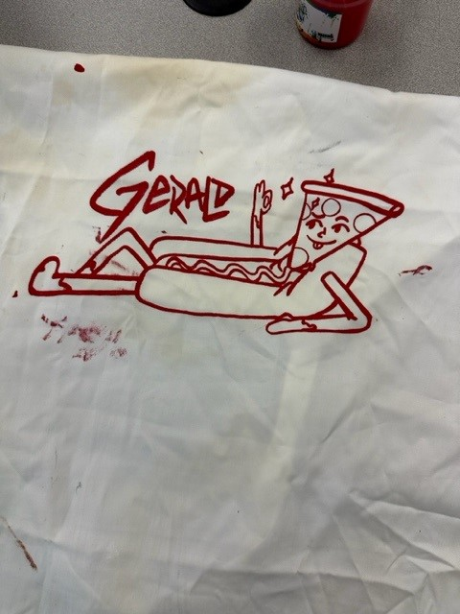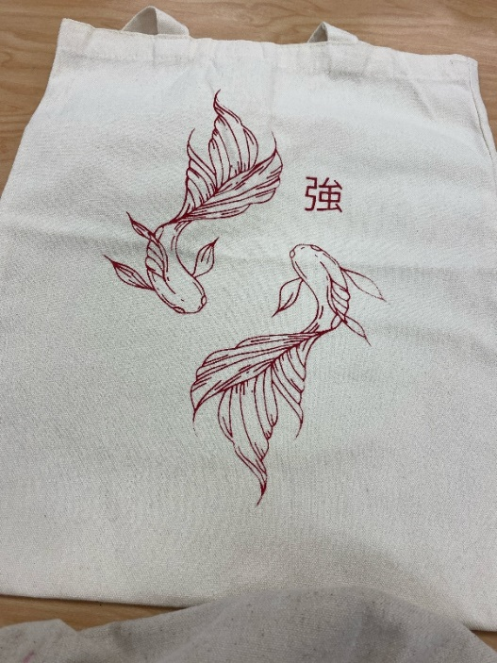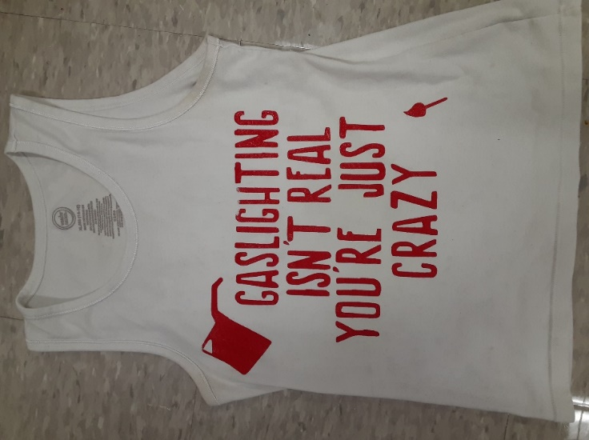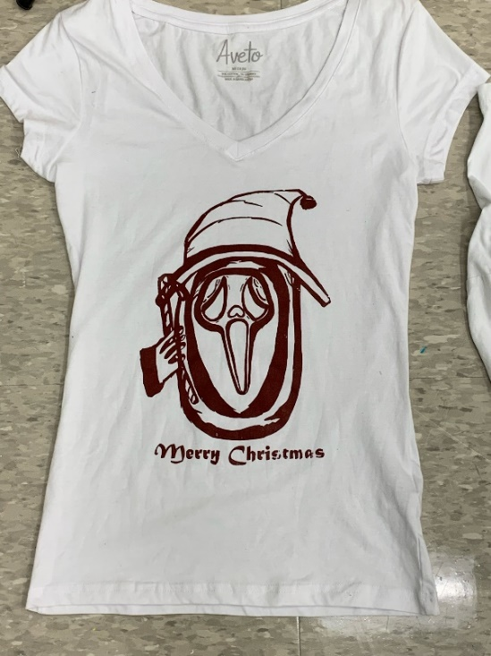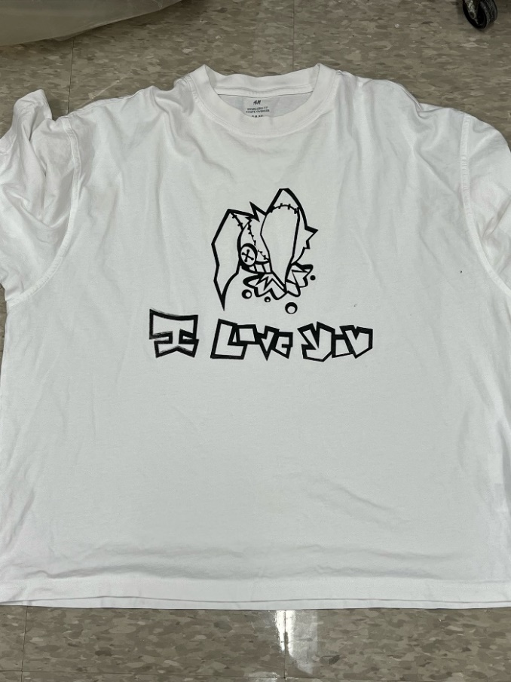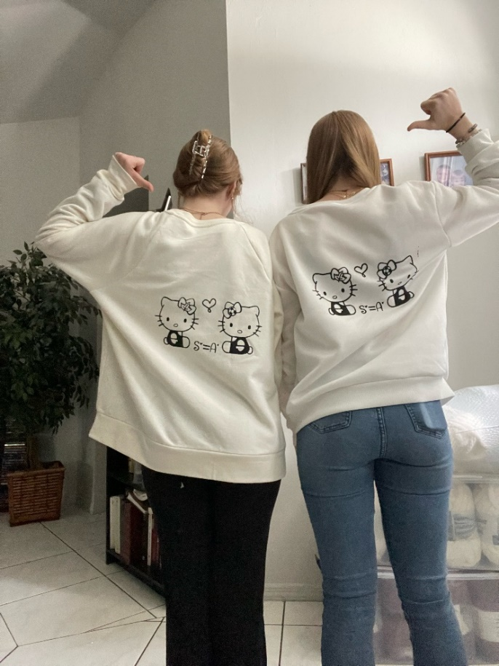
Below are some student samples!

Some student feedback:

“I did enjoy this project; it was a new experience.”
“I enjoyed this project because it made me live out my dream of making a shirt with my personal design on it.”
“Yes, I enjoyed it, because at the end it was really nice to see my own design on something I can wear and show off to other people.”
“I loved this project because it’s something different and it’s something I can tell other people that I did.”

Adrianna Flores, Digital Art Teacher, Palmetto Ridge High School

