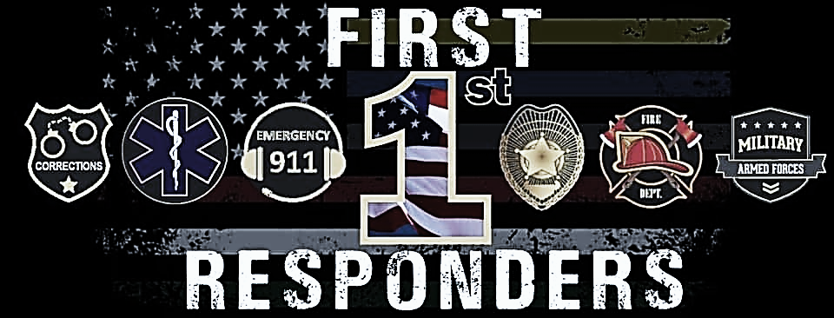
First Responders Field Day at Lely High School
Friday, January 27, 2023
COME EXPLORE!
7:10 am until 2:00 pm
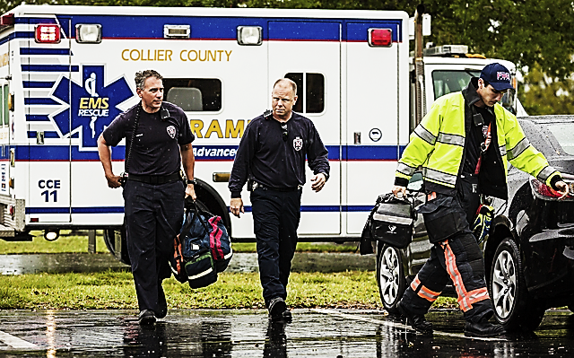
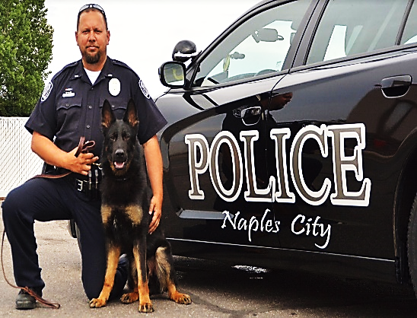
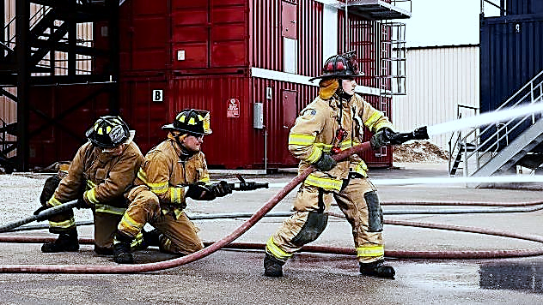
Law Enforcement Firefighting EMS

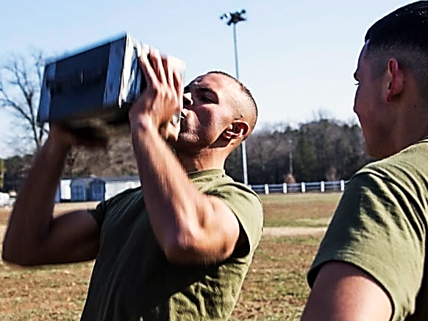
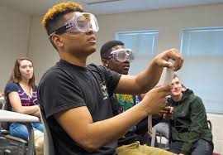
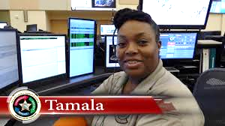
911 Dispatching Fatal Vision Goggles U.S. Marine Corps
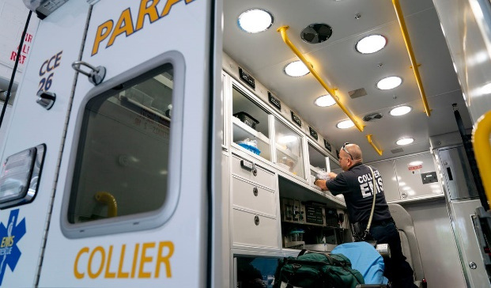
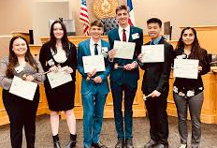
Lorenzo Walker Crime Scene Teen Court

Events
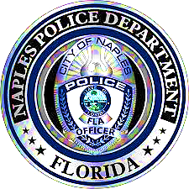
Naples Police Department
Florida Department of Law Enforcement
Physical Abilities Course
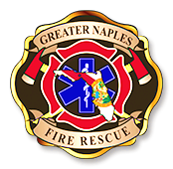
Greater Naples Fire Rescue
Firefighter Challenge
Drag the hose line
United States Marine Corps
Modified Combat Fitness Test
Ammo Can Lifts, Carry your Buddy (Dummy)

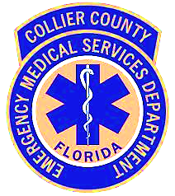
Collier County Emergency Medical Services
Paramedics
Medical First Aid
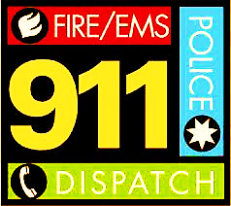
Collier County Sheriff’s Office
Mutual Aid Dispatch Interoperable Communication
Unit MAD-ICU

Lely High School
Criminal Justice Academy
Fatal Vision Goggles Impairment Activity
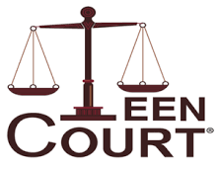
Teen Court Presentation
Coordinator Mr. Turner

Lorenzo Walker Technical College
Workforce Advisor
Technical Programs

