Lely High School
Criminal Justice Academy
Advisory Board Meeting Minutes
October 13, 2022

Jennifer Bledsoe, Principal, Lely High School
Jessie Garcia, Assistant Principal of Curriculum, Lely High School
Nicole Litchko, Assistant Director, Teaching and Learning, CCPS
Maureen DeLacy, Criminal Justice Academy Director / Teacher, LHS
Richard Mackert, Criminal Justice Teacher, LHS
Mara Marzano, Traffic Homicide Prosecutor, 20th Judicial Circuit
Juan Camps, Assistant Chief, Collier County EMS
Andy Krajewski, Assistant Chief, Training Division, Greater Naples Fire
Sgt. Grunewald, Naples Recruiter, United State Marine Corps
Rene Gonzalez, Lieutenant, Community Outreach, CCSO
Amy Taft, Manager, 911 Telecommunications, CCSO
Brooke Sanchez, Training Supervisor, 911 Telecommunications, CCSO
Drew Turner, Coordinator, Teen Court, Collier County
________________________________________________
Introductions: As most members were new to the Lely High School Criminal Justice Academy Advisory Board, participants introduced themselves, their occupation, and a description of the agency and division that each works.
Purpose: Ms. DeLacy described the purpose of the Criminal Justice Academy Advisory Board and the academy’s mission to build partnerships with local organizations to prepare students for the workforce and to introduce students to potential employers.
Career and Technical Education: The Criminal Justice Academy is a four year program that prepares students for careers in criminal justice, public safety, and law by:
- Helping meet industry demand for a skilled workforce by providing opportunities for students to receive training, learn skills, and gain experience in an industry.
- Are based on rigorous academic and employability skill requirements.
- Promote student engagement through mentorship with instructors, supervisors, industry managers, and community professionals.

Lely High School
Criminal Justice Academy
Advisory Board Meeting Minutes
October 13, 2022

Work Based Learning Opportunities: The Criminal Justice Academy strives to provide work-based learning opportunities for students to apply their knowledge and skills to the workplace. The list below describes the types of opportunities that students are eligible to participate in.
Career Exploration: Raising student awareness of a broad spectrum of career paths.
- Career Fairs
- Interest Inventories
- Guest Speakers
- Mock Interviews

Career Exposure: Introduction to an industry and associated occupations.
- Job Shadowing
- Mentoring
- Informational Interviews
- Company Tours
- Externships

Career Engagement: Firsthand engagement in entry-level work based learning.
- School-Based Enterprise
- Service Learning
- Guided Entrepreneurship
- Industry/
- Capstone Project
- Virtual/Simulated work-based learning

Career Experience: Sustained, in-depth, occupation specific, skill-building work-based learning.
- Internships
- Cooperative Education On-the-Job Training (OJT)
  - Clinicals
  - Practicums
  - Apprenticeship OJT
- Pre-apprenticeship OJT
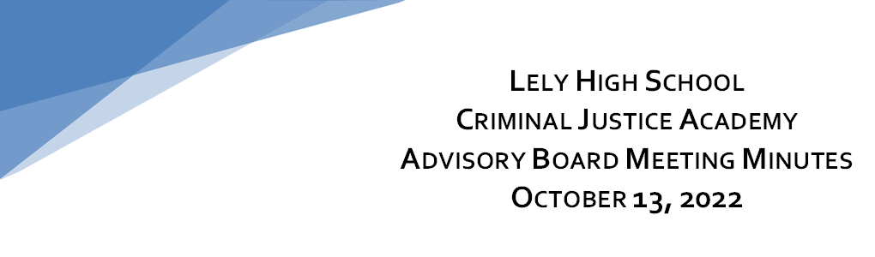
Upcoming events include:
Field Trips
    - Holocaust Museum of Naples November 8 and 9
    - USMC Modified Combat Fitness Test (January 2022)

Districtwide Activities
- First Responder Career Fair - Cancelled until further notice due to Hurricane Ian.
  - Build My Future Career Fair – February 9, 2022

Ongoing Schoolwide Activities:

- Teen Court
- Criminal Justice Club
      - Mock Trial Competitive Team

We sincerely thank you for your participation on the Lely High School Criminal Justice Academy Advisory Board. We look forward to working with each of you to achieve our goal of preparing our students for tomorrow’s workforce.
If you are able to assist us with any of the work-based learning opportunities listed above, please contact Maureen DeLacy.

Warm Regards,
Maureen DeLacy
Criminal Justice Instructor
Criminal Justice Academy Director
Lely High School
Naples, FL 34113
239-377-9043
Email: delacm3@collierschools.com.

