Search for:

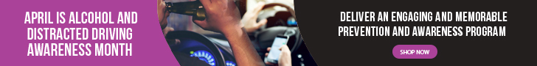

CREATING NEW PERSPECTIVES TO PROMOTE HEALTHY CHOICES

HOME ⁄ PRODUCTS ⁄ ALCOHOL GOGGLES ⁄ ALCOHOL GOGGLES ⁄ FATAL VISION® IMPAIRMENT GOGGLES

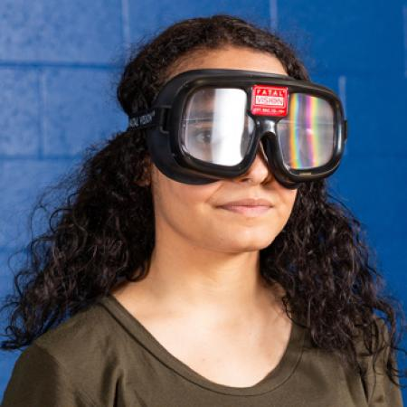

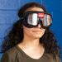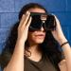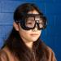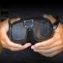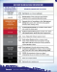
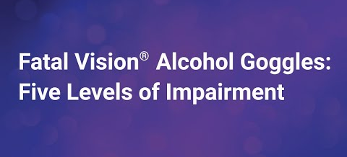

Fatal Vision® Impairment Goggles

The Fatal Vision® Alcohol Goggles deliver memorable lessons on topics like impaired driving, underage drinking, and other substance abuse issues. Participants perform simple activities or sobriety tests without and then with the goggles. Performing the activities twice lets participants experience their performance while unimpaired and then impaired. The goggles cause the wearer to display behaviors that are typical of individuals impaired by alcohol at various BAC level.
Each goggle includes a cleaning cloth bag and one (1) printed Fatal Vision® User Guide.

When you are under the influence of alcohol, it can be difficult to gauge just how impaired you are. Enter the Fatal Vision® Alcohol Impairment Simulation Goggles, an eye-opening tool through which sober people can experience potential consequences of doing basic tasks after drinking.
Walking a line, standing on one leg, reaching out to grab a set of keys and tossing a ball become much more difficult under the influence of alcohol. The Fatal Vision Goggles give participants a safe way to learn the important lesson that alcohol greatly impairs a person’s balance, vision, reaction time and judgment.

Fatal Vision is available in five levels that simulate the impairments associated with a particular blood alcohol concentration (BAC) – from less than .06 to .25+ BAC. Fatal Vision is available with either a clear lens to simulate day conditions or a shaded lens to simulate night conditions.
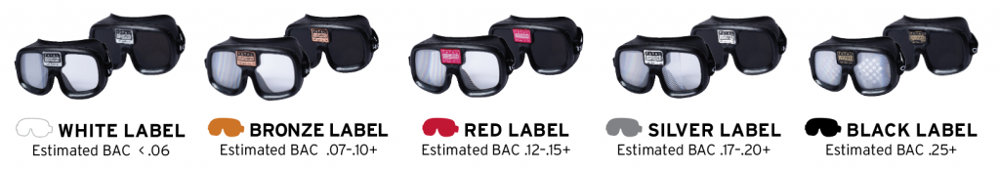
- Fatal Vision White Label Goggles – (estimated B.A.C. of < .06) Impairment begins with the first drink
The White Label goggle simulates a low level of impairment, an estimated BAC of less than .06. Studies show that even one drink will affect a person’s reaction time and their abilities. The effect of the White Label goggle will be subtle, as in the beginning stages of low impairment. An effective method of demonstrating the effects of impairment is to set up an activity course of multiple tasks and time the participant completing those tasks. Most tasks are short and routine in nature and the impairment may not be immediately obvious while performing just one task. When multiple tasks are required, the participant will likely slow down and may make more mistakes.
- Fatal Vision Bronze Label Goggles – (estimated B.A.C. of .07 – .10+) Legal limit of impairment
The Bronze Label goggle simulates a low to moderate level of impairment, an estimated BAC of .07 to .10+. Impairment is more apparent and easily recognized. At this stage of impairment, timing the activities may not be required to see the effect of impairment.
- Fatal Vision Red Label Goggles – (estimated B.A.C. of .12 – .15+) National average of DUI offenders
The Red Label goggle simulates a moderate to high level of impairment, an estimated BAC of .12 to .15+. Impairment is more apparent and easily recognized.
- Fatal Vision Silver Label Goggles – (estimated B.A.C. of .17 – .20+) Original Fatal Vision Goggles
The Silver Label goggle simulates a high level of impairment, an estimated BAC of .17 to .20+. Impairment is obvious at this stage. Even simple tasks will be difficult to complete. If you are in a school, use top athletes demonstrating their skills, first without and then with Fatal Vision® to show that no matter how skilled someone is, they cannot overcome the effects of impairment to complete a task.
- Fatal Vision Black Label Goggles – (estimated B.A.C. of .25+) Binge drinking
The Black Label goggle simulates a very high level of impairment, an estimated BAC of .25+. Use this goggle to educate people about the risks of “Binge Drinking” or High-Risk drinking.
- Each set of Fatal Vision Goggles include a cleaning cloth bag and one printed Fatal Vision User Guide.

The safety of our customers and other users of our products has always been, and will continue to be, a top priority.
