TITLE: Basket Weaving
Learning Goal(s):
- The student will learn about African Culture and Basket Weaving
- The student will learn to identify and create woven baskets in the style of traditional African baskets
- The student will learn to identify traditional patterns and methods used in African baskets
Florida Standards/Benchmarks:
VA.68.H.1.3: | Analyze and describe the significance of artwork from a selected group or culture to explain its importance to the population.
VA.68.S.1.4: | Use accurate art vocabulary to explain the creative and art-making processes.
VA.68.S.1.5: | Explore various subject matter, themes, and historical or cultural events to develop an image that communicates artistic intent.

Vocabulary:

Base
Rim
Stakes/Spokes
Ribs
Over/Under
Coiling
Pattern
Weaving

Resources/Links:
History of African Baskets
History of Basket Weaving -general
Basket Weaving Resources, Techniques, and More!
What is a Basket?
Video: Woven Bowls from Paper Plates
Video: Dick Blick Saucer Baskets
Video: How to Make a Yarn Bowl
Video: Creating a Coil Basket

Media/Materials:
- Paper Plates & Yarn
- Coiling Cord/Braiding Cord, Yarn, Large Needles
- Reed or Came, Yarn, Recycled Materials
- Local plants, grasses, found materials
Directions:
- Introduce students to African Basket Weaving.
- Look at and/or create a handout with information and visual examples.
- Look at a variety of websites with directions for basket weaving
- Choose materials and method you will use for your basket weaving project—different styles and materials were used in different parts of Africa. For example:
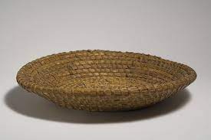
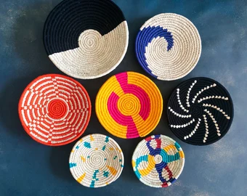
These baskets are made of grasses and other available plant material and are made using the coil method-they are called fanners.
GRADING RUBRIC:
0 (0 points) | 1 (5 points) | 2 (10 points) | 3 (15 points) | 4 (20 points) | SCALE
No basket was made | Incomplete basket, not successfully woven | Partial basket, some weaving elements evident | Well-woven basket completed | Additional elements beyond those required
No craftsmanship, basket falls apart | Parts of the basket stay together | Most of the basket well woven, some edges rough | Basket is tightly woven and stays together | Additional elements beyond those required
No pattern | The beginnings of a pattern | Pattern shows in part of basket | There is at least one pattern evident in finished basket | Detailed and creative use of patterns
No form, basket falls flat | Basket lip rises a little | Basket form is evident, if uneven | Basket form is evident and even | Unique and creative basket form
No name, title, class, no craftsmanship | Missing title, name, and class, poor craftsmanship | Missing title, name, or class, craftsmanship could be improved | Title, student name, and class on back, good craftsmanship | Unique title, name, class, outstanding craftsmanship
Total Score
Reteach/Enrich:

- Work with a partner/peer tutor
- Break down into smaller steps
- Reduce the elements in the assignment
- Make a smaller version
- Make a second project
- Add additional details to original
- Help another student/peer tutor

