Bring “Never Again” to Life
If we are going to bring about an end to the world’s worst atrocities, we have to create a role—we have to make some noise. How do we do this?
Not a single person should go unidentified or forgotten. Small artifacts allow us, as a society, to never forget the mass atrocity known as The Holocaust. While we do not have actual artifacts for our museum, you can create these artifacts that mirror the historical events that took place nearly seventy-five years ago. It is important that you create an unbiased and accurate depiction of the people and events in this tragedy.

Why are we creating a museum if we are going to be visiting one this year?
What better way to truly empathize with the survivors and victims of the event in history than to view it from their side? By studying a specific person, event, or idea on The Holocaust, you will be truly knowledgeable on that particular exhibit. Then by creating the artifacts yourselves, you are using your creativity to put yourselves in the shoes of those who lived during this atrocity. You cannot understand the words of Anne Frank, Elie Wiesel or any of the other world renown authors who wrote of this tragedy if you do not know the context.

When confronted with a powerful image, we have a choice: we can look away or we can address the image.
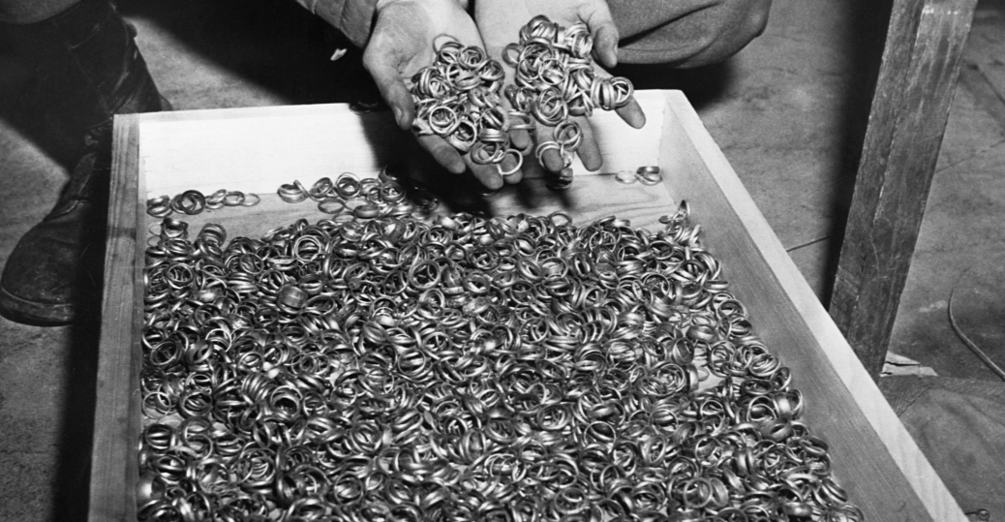
A few of the thousands of wedding rings the Nazis removed from their victims to salvage the gold. U.S. troops found rings, watches, precious stones, eyeglasses, and gold fillings, near the Buchenwald concentration camp. Germany, May 5, 1945.

Your Task

Skills Required: Planning, Analysis, Synthesis, Collaboration, Evaluation, and Communication.

Directive: Design a museum exhibit to teach about a given topic from The Holocaust. Your exhibit should include _______ artifacts with plaques. Each artifact should also include a written description and explanation of its significance. Your exhibit should be engaging to museum visitors, so be creative and consider constructing a 3-D artifact and adding an interactive feature to your exhibit where visitors can participate in the exhibit.

*If you wish to research and present a topic in another format other than a museum exhibit, please discuss it with me.

Due Date: ___________________________

Points: ______________________________

Extension:

- Create a quiz/test
- Create an iMovie
- Create a Blendspace
- Create an EdPuzzle
- Create a Discovery Ed Board
- Create a Zaption

Activities
- Plan
20 points
Due Date:________________
You and your group must collaborate to create a plan* stating:
- what materials will be used
- job roles (suggestion: assign according to skill)
- sketch of exhibit
- amount of artifacts
- any other necessary information for creating your exhibit

I suggest using GoogleDocs because it can be shared with all group members (and myself) and edited easily.

*You may edit your plan but it must be updated with every change.
__________________________________________________________________________________________________________
- Research
50 points
Due Date:________________
You will take notes on your research. When you read a valid source, you are required to take notes on the source. Your style of notes is up to your group. I suggest using a style with which you are familiar. How many sources do you need? How many notes do you need?

Again, I suggest keeping these notes in GoogleDocs.
__________________________________________________________________________________________________________
- Analysis
80 points
Due Date:________________
Your group will need to decide which research you will be using in your exhibit. Curators view vast amounts of artifacts and research, but they have to analyze the artifacts and research to determine what is interesting, important, or usual. Ask yourself: Is this something people would want to know/see? I will be looking for a final copy of notes and sources for this activity.
__________________________________________________________________________________________________________
- Product
100 points
Due Date:________________
You will need to use all of the previously mentioned skills to put together a museum exhibit. There are as many different kinds of exhibit styles as there are museums! Every style is different and wonderful in its own way. Enjoy the process and your product will be a success!

Museum Project Learning Contract
By signing this document, you are acknowledging that you are responsible for the listed activities in this assignment. If at any time you demonstrate that you are not responsible enough to appropriately collaborate, work independently, and/or conduct research, you will be written up under “failure to follow a reasonable request.” Inappropriate research or comments will automatically qualify you for a write-up. By signing this document, you are also acknowledging that you are aware that you may come across mature content. It is your ethical and moral responsibility to understand that this project is meant to provide insight to one of the most influential time periods of modern history. You may not generalize, stereotype, or mock any of the fictional or real characters, events, or themes that are presented in these novels. If you do not understand something or would like more information, please do not hesitate to ask for clarity or the opportunity to look something up online. The assignment due dates are subject to change at the teacher’s discretion. The classroom’s late policy still applies.

_____________________________________________________________
Student Name (printed)

X_____________________________________________________________ __________________________
Student Signature Date

