Fantastic Creature Head Notes
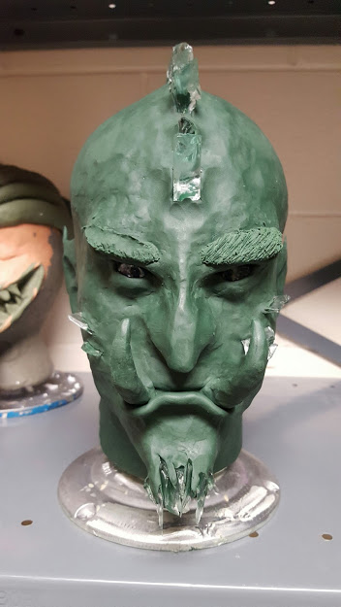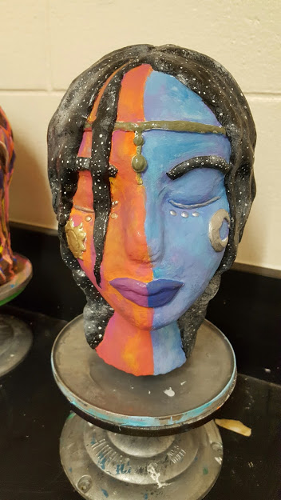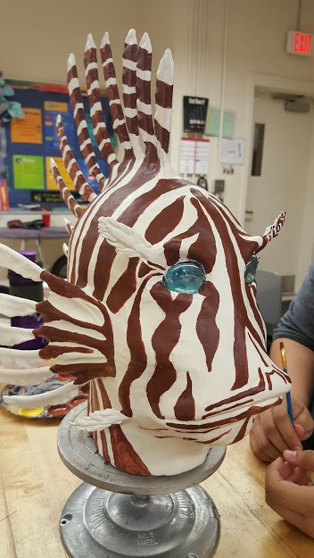
GOAL/What are We doing:
- Creating imaginative heads using 90% clay sculpted, 10% additive materials on Foam Head frames.
- Learning about ART CAREERS: Anaplastologist a/k/a Maxillofacial Prosthetist (medical prosthetics); Medical Sculptor(creates 3D models of anatomy for office use) Hollywood Prosthetic Makeup Artist; Automotive Designer
- Using NON-TRADITIONAL ART MATERIAL: foam head, additives, mod-podge, and experimenting with techniques.
- Creating creatures based off YOUR background knowledge (history, literacy, film, pop culture, etc . . .) and be able to explain your reasoning.
- Practicing FELDMAN’S METHOD OF ART CRITICISM for deeper thinking about your work as an artist.
- Following ALL directions, participating correctly and using our class time wisely.
- Understanding COPYRIGHT LAW and I cannot copy something 100% to make a profit off. Must change at least 20% of an established idea to market as my own for profit.
Vocab:

Feldman’s Art Critique
Describe
Analyze
Interpret
Judgement
Elements of Art

Principles of Design
Sculpture
Bust
Additive Sculpting
Subtractive Sculpting
Ready Made Objects
Found Objects
Anaplastologist
Prosthetic Makeup Artist
Medical Sculptor
Automotive Designer

Parts of this PROCESS:
- Students will copy notes to strengthen AVID skill of seeing/processing/ writing.
- Brainstorming and 3 thumbnail sketches of 3 DIFFERENT creature ideas to really figure out the elements/principles best liked.
  - Conference with Tablemates then Teacher over strongest design.
- Create one larger color sketch to map out traditional and non-traditional materials, and test color schemes.
- Create 1 lb MAQUETTE for preliminary model bust
- ONCE YOU MEET ALL OF THESE MINI GOALS LEADING UP TO PRODUCTION, THEN YOU WILL BE ABLE TO START ON YOUR FOAM HEAD.
- AFTER your creature is done, you will complete the self-evaluation and artist statement as part of a project grade.
- There will be WICOR DAYS where you will be reading articles.
Evaluating Your Work with the Four Steps of Art Criticism:
- Describe: Explain your creature: (What do you see, what added media did you choose?)

- Analyze: Use your art vocabulary (Elements and Principles) to explain your work:

- Interpret: Describe the feeling your creature convey to viewers (if unsure, ask tablemates):

- Judge: What do you think of your final product, and what would you change to improve it now that you’ve worked through this process?

Last Question: What do you think you earned on this project?_________Did you like this one more or less than other projects?_______________________ Please tell me one thing you really liked about it AND one thing you did not like about this process:

