Ms. Lunt,
I wanted to thank the Nassau Education Foundation for the grant funds we received last year. We put the monies to good use creating a STEAM Kit Lending Library at Yulee Primary School. I am attaching a few documents to help you envision the STEAM Kits in action.
I’ve also included the flier sent out to teachers inviting them to utilize the Lending Library, plus copies of our check out records. As you can see, the Lending Library gets a lot of business. In addition to the activity kits your grant paid for, our Lending Library contains materials ranging from plastic Solo Cups for Engineering Cup Castles, to Plasma Balls for studying static electricity, to animal furs for doing mammal studies.
This year, the Lending Library has reached beyond the bounds of Yulee Primary to share materials with both Callahan Elementary and Wildlight Elementary. We’re looking forward to building stronger relationships among the schools so that materials need not be duplicated at different sites.
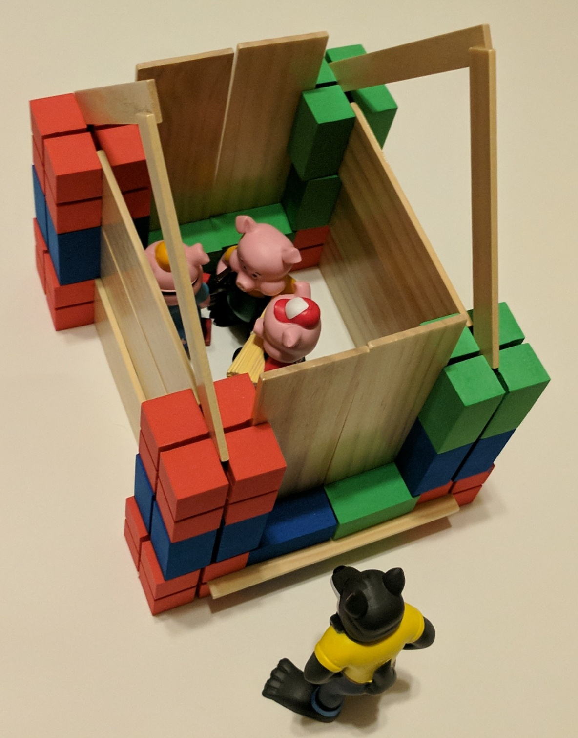
Let me thank you again for helping us develop our STEAM Kit Lending Library. Have a great Spring Break!
Sincerely,
Kelley MacCabe
YPS STEAM Lab
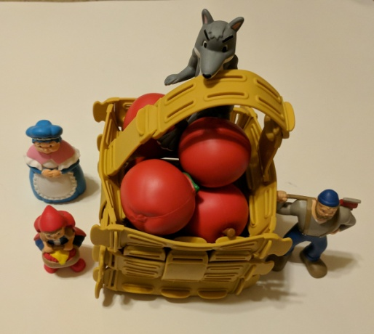

“Little Red Riding Hood Challenge” “Three Little Pigs Challenge”

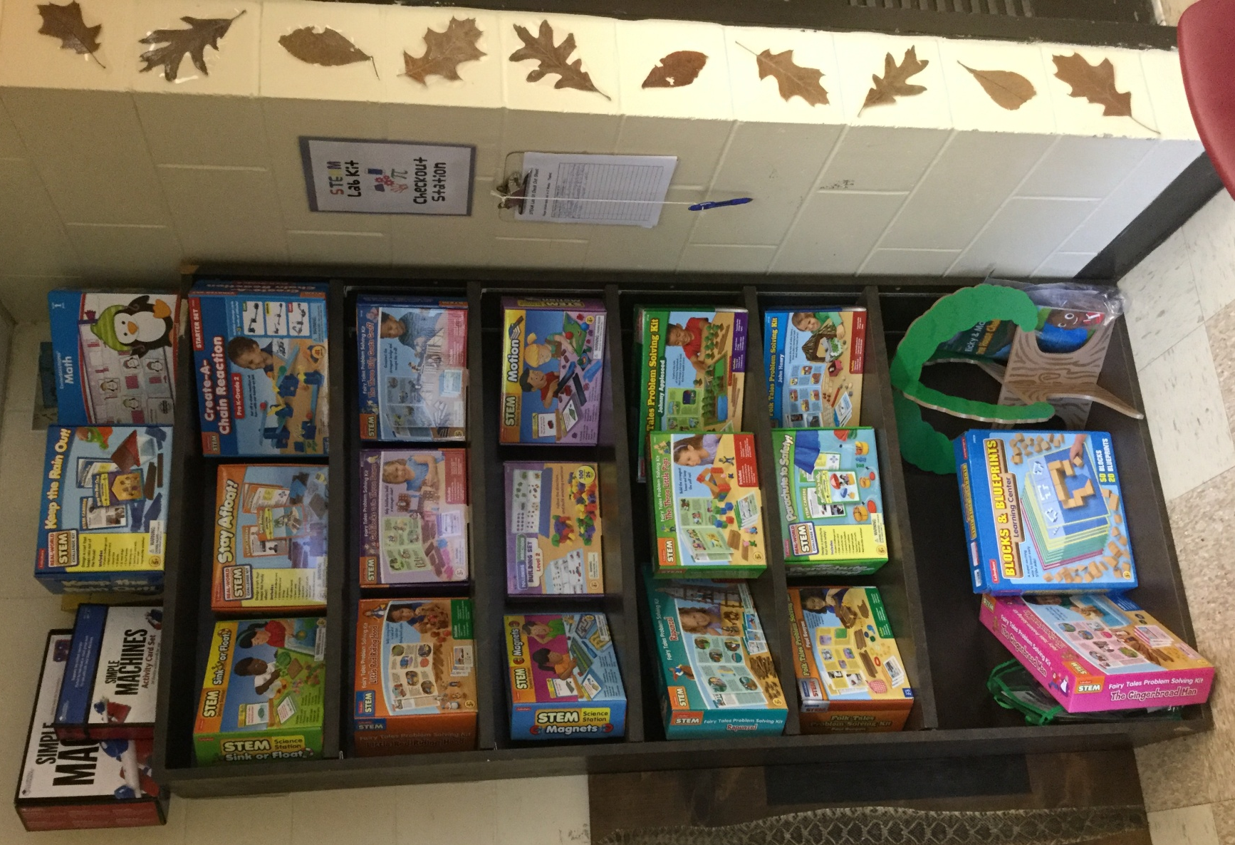
Yulee Primary School
STEAM Lending Library
Check Out STEAM Kits for K-2nd

Teachers,

Last year I was awarded a grant to build a Lending Library of STEAM Kits you can use in your classroom.

As Winter Break approaches, this is a great time to try out a STEAM Kit in your classroom! I’ve tested each Kit myself and photographed one possible solution to each challenge to give you a head start.

Many of the kits are based on a fairy tales or legends and require 20 minutes or more to build a solution. These work great as activities for early finishers and indoor recess.

Other kits include several challenge cards, each of which may take 2-7 minutes. These work well as center materials (and indoor recess too).

Both kinds of Kit provide opportunities for fun and learning – with little extra preparation on your part!

Please see the list of available Kits on the back. Watch your email for descriptions and pictures of each Kit.

A number of teachers have already sampled the materials, and their students are really enjoying them!

If you would like to check out a Kit, come into STEAM Lab when you bring your class. There’s a sign-out sheet on the STEAM Kit bookcase. Before giving a Kit to your students, please be sure to give yourself a few minutes to read through each Kit’s Teacher Tips and familiarize yourself with the materials. Enjoy!

[See back for list of STEAM Kits you can check out today!]
What’s in the STEAM Lending Library?

Geometry-Related Kits: (K-2nd) Previewing these 3 activities in STEAM Lab.
These have challenge cards and work well as 5-10 minute center activities.
- Blocks & Blueprints
- Following Directions Building Set 2
- GeoStix

Kits with a Fairy Tale or Folklore Theme (Literature meets Problem Solving):
(1st and 2nd) These take at least 20 minutes for one student (or a small group of students) to complete.
- Rapunzel
- Goldilocks
- The Three Little Pigs
- The Gingerbread Man
- Little Red Riding Hood
- The Three Billy Goats Gruff
- Paul Bunyan
- Johnny Appleseed
- John Henry
- Tree House Challenge (Not a fairy tale, but just as fun!)

Kits with a Single Scientific Theme: (K-2nd)
These have challenge cards and take varying amounts of time to complete.
- Create a Chain Reaction
- Engineer a Coaster
- Magnets
- Parachute to Safety
- Motion Kit
- Mechanical Engineering Gear Kit
- Sink or Float
- Keep the Rain Out
- Stay Afloat

~I hope these Kits will be a great addition to your classrooms!~
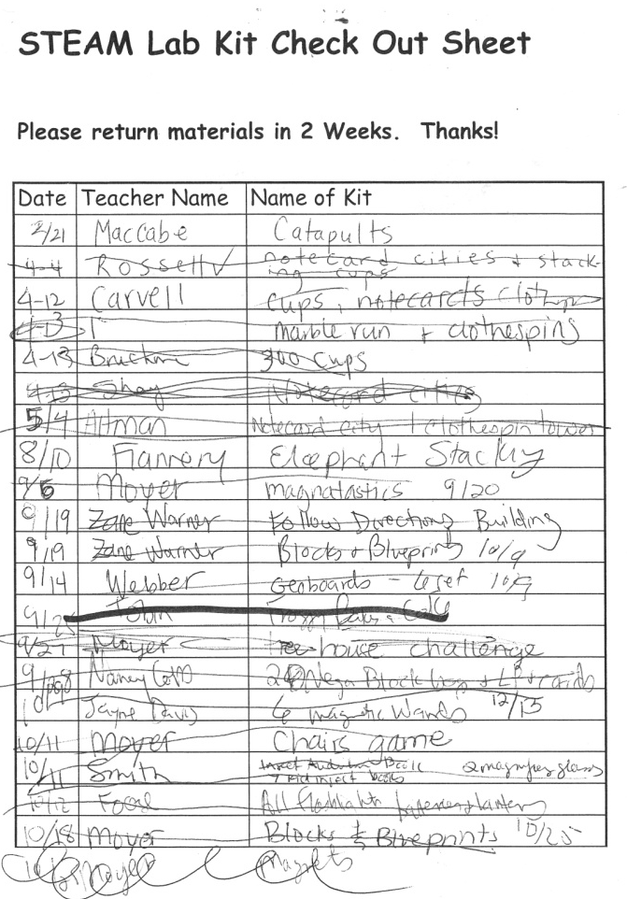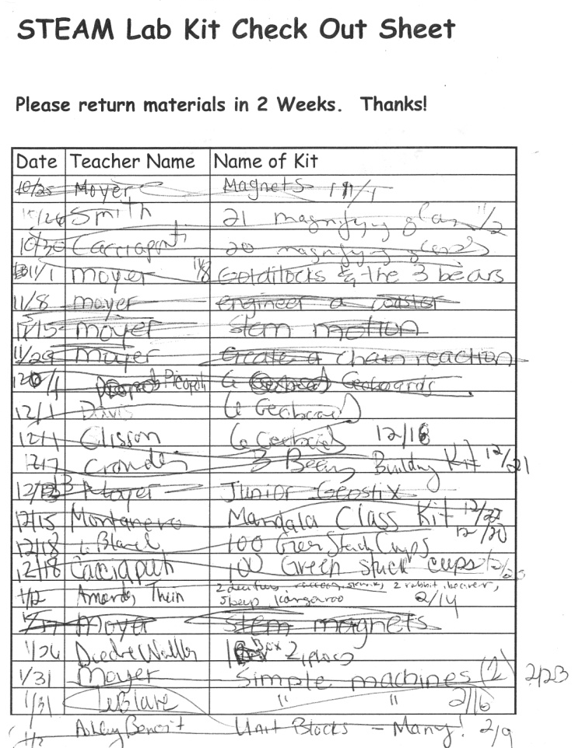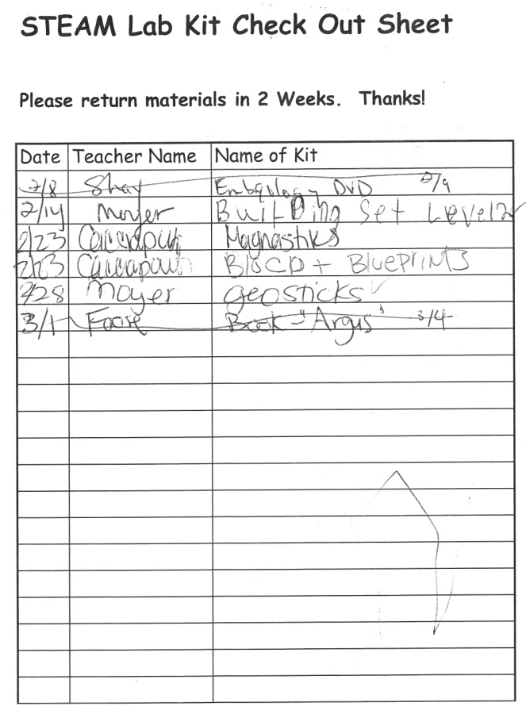
The STEAM Lending Library gets plenty of use. One class voted to have indoor recess each Thursday so they could do more STEAM activities. They’re our best customers!

