Our school is in a rural tourist destination area. We have been severely impacted by Covid as a result. This has impacted our ability to solicit sponsorships from businesses and private parties. We hope this impact will be lessened by next season.
The Magnet Innovation Center (MIC) is a specialized STEAM (Science, Technology, Engineering, Art, and Mathematics) program that is part of South Walton High School. MIC is an accelerated public high school which houses students in grades nine through twelve. At the heart of MIC is its dedication to the high-impact learning experiences in math, engineering, robotics, Project Lead the Way programs, FIRST®, SeaPerch, BEST, and science. It is through these experiences that sets MIC apart from other high schools in Walton County and provides for enriching and engaging learning experiences rooted in STEM. MIC aims to lift the performance ceiling of the students, fuel their creativity and passions, and encourage students to pursue STEM degrees as they matriculate to college. If awarded this grant, over 125 students at MIC and South Walton High School benefit from participating in the hands-on engineering experiences offered through Project Lead the Way as well as the FIRST robotics programs. Representative sponsors for FIRST include NASA and Boeing along with professionals from engineering career fields that have a passion for math and science.
The mission statement for MIC is “Through innovative science, technology, engineering, art, and math academic programs aligned with community partnerships, we CHALLENGE students to be intellectually curious, to think critically, and to be creative problem-solvers so they may ACHIEVE higher levels of learning and EXCEL as the next generation of STEAM leaders". To support this mission statement, opportunities are continually being sought out to provide programs that will challenge the students and lead them towards a STEM career pathway. The primary goal of this grant is to provide the necessary equipment and materials to support the FIRST® robotics team and build a foundation of knowledge within the field of robotics and coding which leads to extending each students' opportunity to advance in the field of technology and software coding.
FIRST® (For Inspiration and Recognition of Science and Technology) is a robotics community that prepares young people for the future through a suite of inclusive, team-based robotics programs for ages 4-18 (PreK-12) that can be facilitated in school or in structured afterschool programs. Boosted by a global support system of volunteers, educators, and sponsors that include over 200 of the Fortune 500 companies, teams operate under a signature set of FIRST® Core Values to conduct research, fundraise, design, build, and showcase their achievements during annual challenges. An international not-for-profit organization (501(c)(3)) founded by accomplished inventor Dean Kamen in 1989, FIRST® has a proven impact on STEM learning, interest, and skill-building well beyond high school. Our goal of training the next generation of STEM leaders to actively investigate, to question current practice, and to design new solutions to local and global problems will be supported by this grant opportunity.
The 2021-2022 Robotics team at MIC is an after-school club that inspires STEAM students to become creative at solving problems in the physical world through FIRST® robotics programs. MIC students compete in arena, underwater, and drone competitions throughout the school year. Students come together as a team and learn how to create solutions for the FIRST® robotics competition by defining the problems, presenting possible real-world solutions in a Decision Matrix, physically building prototypes, computer coding, testing prototypes, and redesigning final solutions. An example of a real-world application of the knowledge students acquire for solving problems includes analyzing challenges presented by Boeing regarding delivery drones that require coding, and the understanding of how artificial intelligence is applied to these situations. Exploring how NASA utilizes its rover for space exploration provides an additional opportunity for students to explore other situations where using rovers would be extremely beneficial and efficient. Throughout the school year, the students’ work and perseverance culminates in a regional competition which is held in Orlando, Florida. The entry fee for this competition is $5000.00 per team and must be raised annually. This fee does not include the extra parts that are required to build the robot, travel expenses for the team, and lodging for the three-day competition. We are requesting this grant to help offset expenses related to this competition.
The mission of FIRST® is to inspire young people to be leaders and innovators by engaging them in programs that cultivate science, engineering, and technology skills, inspire innovation, and foster well-rounded life capabilities including self-confidence, communication, collaboration, and leadership. By participating in FIRST® programs, students are engaged in exciting mentorships, research, and robotics programming that help them become the next generation of STEM leaders. FIRST® works because these programs use research-based strategies known to increase student interest and engagement in STEM. Strategies such as hands-on learning, collaborating as a team to solve real-life problems, exposure to careers and adult mentors, emphasis on FIRST® Core Values, and the opportunity to present their robotic solutions and research during a showcase allows these students to be recognized by local industry and community partners thereby creating connections for future employment and internships within STEM fields. FIRST® participants are prepared for success in school and the workforce, no matter what path they take.

Team Registration Information
2022 Team Registration for FIRST® teams includes:
- 2022 Season Registration.
- FIRST® Robotics Competition (note: registration fees do not cover duties, fees, or taxes associated with shipping Kit of Parts items, nor do they cover shipping Kickoff Kits to team locations or shipping FIRST® Choice material.)
- Kickoff Kit
- Virtual Kit and credits for FIRST® Choice
- Eligibility for submitted Awards, including Chairman’s Award (veterans only), Dean’s List, and Woodie Flowers Finalist Award
- Team member access to FIRST®®'s Scholarship Program
- Participation at one (1) Regional Event for Regional Teams and participation at two (2) District Events for District Teams
Team Registration does not include any duties, fees, or taxes to ship the Kickoff Kit or FIRST® Choice items. These fees also do not include any in-person Event Registration costs. The invoice for the team registration is shown below.

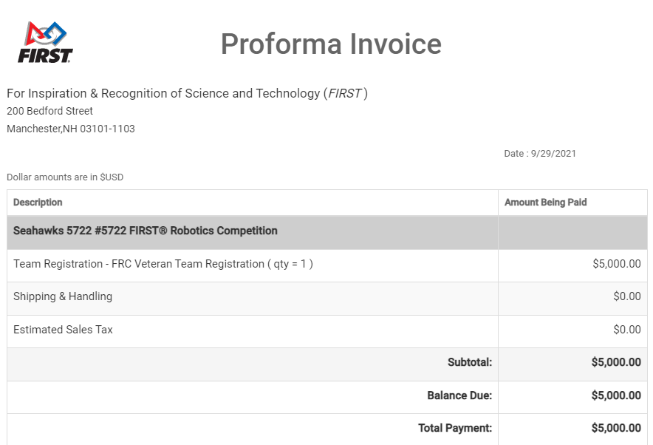
FIRST FRC competition
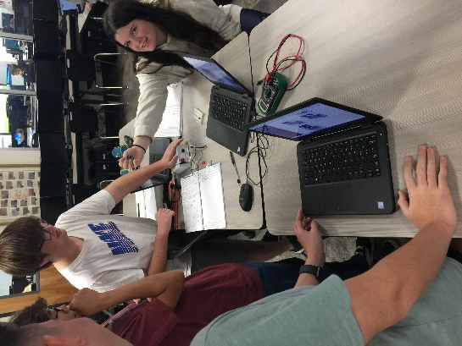
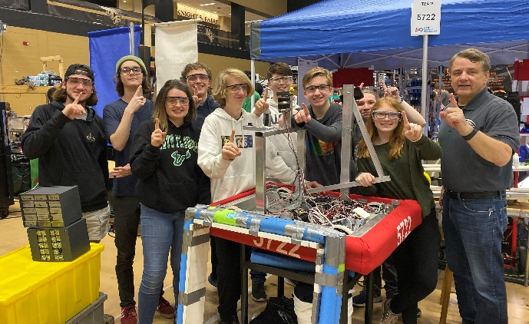
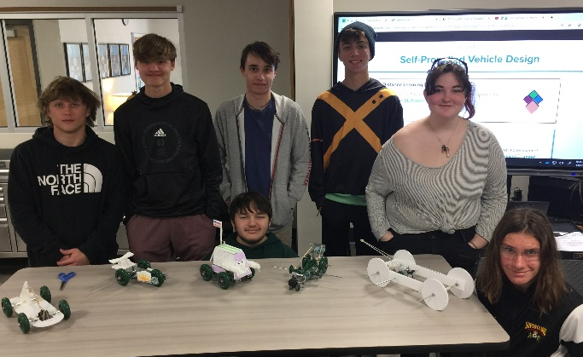
Building and testing prototypes
Sea Perch competition for aquatic rovers
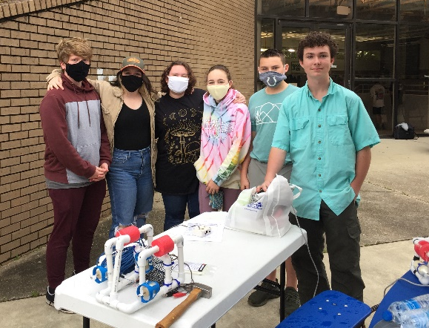
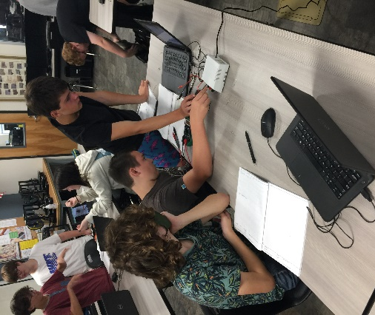
Coding and Engineering challenges through
PLTW courses
Testing electrical conductivity

